WEBSITE CONTENT

- Cover page
- Training centre name belong with government recognized skill development training centre affiliated full details
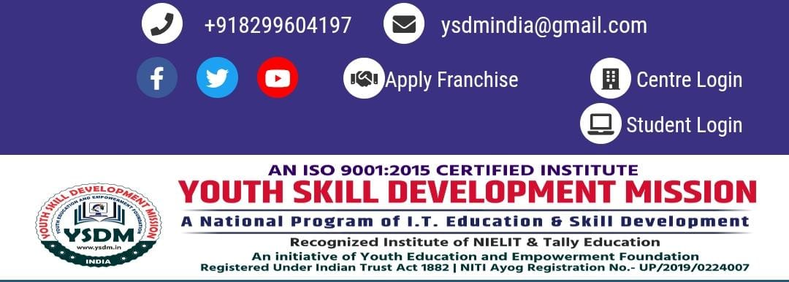
- Address , gmail , social media Id , phone number , website.
- Institution logo .

- Table of contents
- Home
- About the Organization
- Our Service & Function
- Programs & Government Initiatives
- Resources & Important Links
- Registration
- Examination & Results
- Online Verification
- Contact & Support
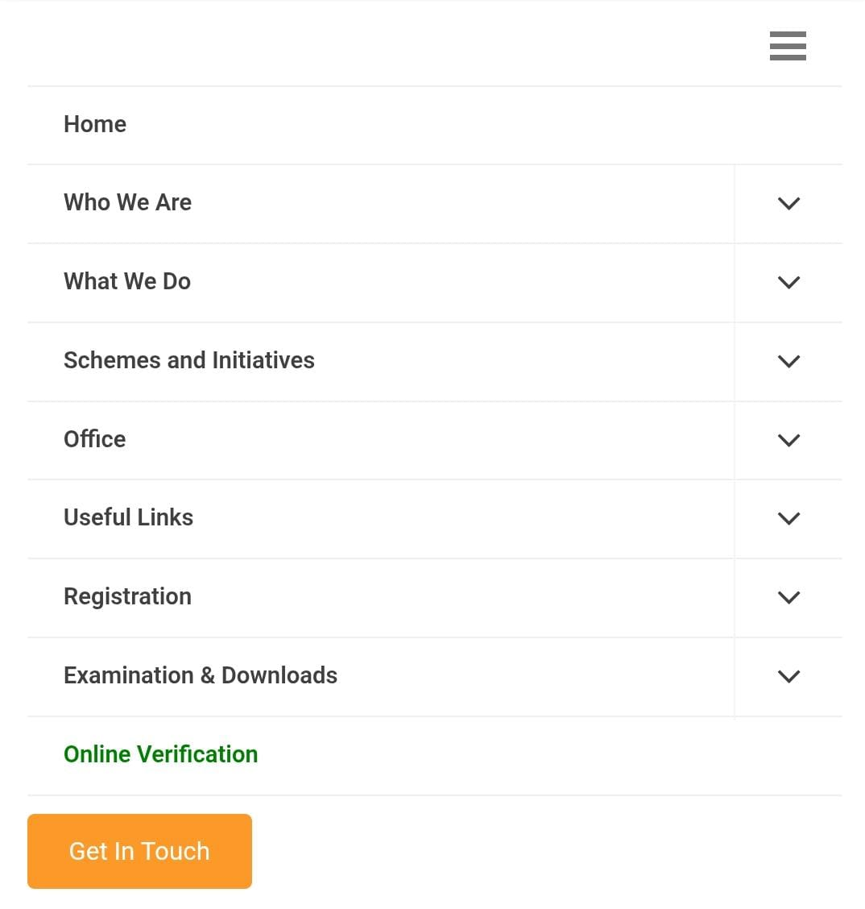
- Home
- When it was established .
- Purpose of starting the training centre.
- Government style objective.
- Target students & achievements.
- Online contact form.
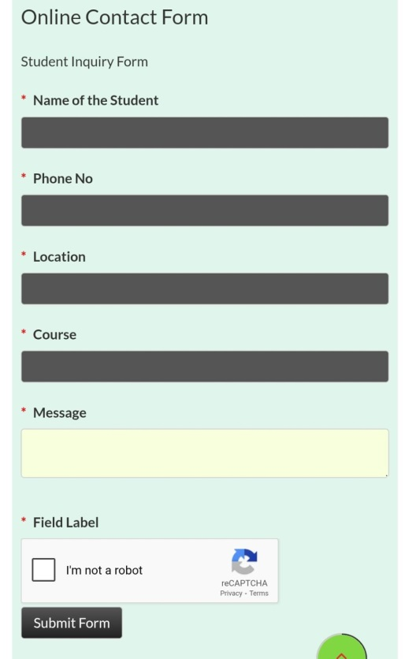
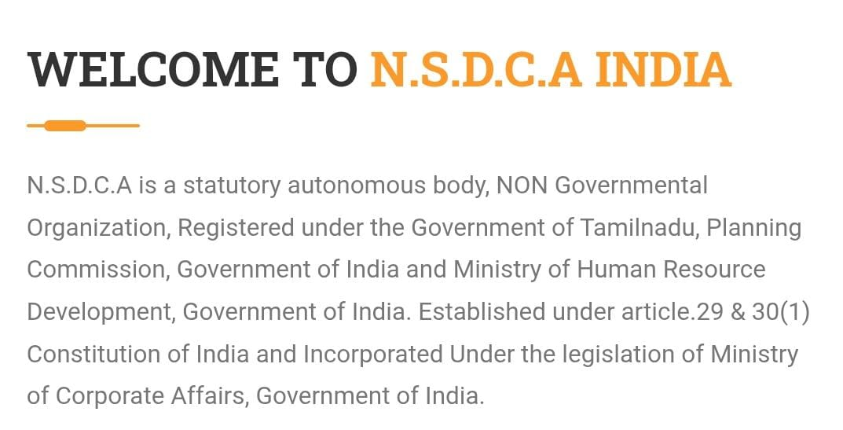

WELCOME TO NAVIGATING CAREER FOR VOCATIONAL SKILL TECHNOLOGY COUNCIL
N.C.V.S.T.C Vocational Educational Council is a statutory autonomous body, NON Governmental Organization, Registered under the Government of Tamilnadu, Planning Commission, Government of India and Ministry of Human Resource Development, Government of India .Established under article.29 & 30(1) Constitution of India and Incorporated Under the legislation of Ministry of Corporate Affairs, Government of India .Conducts the courses in Non-Formal mode through Online, Open and Distance Learning. Currently NCVSTC conducts Elementary Education, Preparatory Programme, OBE Programme, ESLC Programme, Secondary Education, Higher Secondary Education (First and Second Year), Certificate Courses, Diploma Courses, Degree Course, Post Graduate Diploma Courses, Technical Courses, Management Courses and various sectors related to Skill and Vocational Education school educational, Arts & Technical Education courses through
Study centers,
Vocational Training Provider (VTP),
Community College (CC),
Industry Training Institution (ITI),
Skill Training Institution (STI),
Skill Training Provider (STP),
Basic Training Provider (BTP),
Online and Distance educational mode, schools and Colleges across ASIA
We pledge to give you a modern, robust and competitive education so that you will graduate to become responsible and responsive citizens of your various communities and our country. It is also our solemn resolve to inculcate into you the need to be enterprising so that you can become self-reliant at the end of your studies. We pledge to give you a modern, robust and competitive education so that you will graduate to become responsible and responsive citizens of your various communities and our country. It is also our solemn resolve to inculcate into you the need to be enterprising so that you can become self-reliant at the end of your studies.
We appreciate the fact that we are in the age of computerization and technology. We therefore will ensure that courses and the way courses are taught are IT-compliant. In order to achieve our goals we expect our students to be conscientious and hardworking. We intend to mould both the character and learning traits into our students as these are ingredients for a successful future.
To our members of staff, we will aspire to provide you with a conducive atmosphere to enable you to make your salutary contributions to this online institution so that we can all be proud of it at the end of the day.
Already, a strong rapport has been established with the host community of the INDIA. We must all build on this happy beginning.
ATTESTATION OF CERTIFICATES
The Certificates of the NCVSTC Vocational Education Council get Attestation from Foreign Embassies for Education and Employment purposes. Being a NON-UGC Programme, the Certificates of the NCVSTC are not recommended for PSC/UPSC Appointments. It is widely used in Public Sector Undertakings, Multi-National Companies and Private Sector in India and abroad who are satisfied with the Official Verification System.
Legal Value
NCVSTC Vocational Educational Council is a Private, No- Governmental statutory autonomous Education body of online, Open & Distance Learning and its Recognized Registered body under incorporated MCA act 1956 sec 8 Ministry of Corporate Affairs, Government of India.
Under Human Rights Protection Act-1993, autonomous bodies have been given special protection & consideration. (For Further details refer. AIR 1993 SC – 2178).
Under Human Rights Protection Act 1993, autonomous body have been given special protection and consideration. According to J.P. Unnikrishnan Vs Govt. of Andhra Pradesh AIR 1993 Supreme Court 2178 verdict voluntary organization like Trusts, Societies etc… have right to spread education and issue Certificates for Degrees/Diplomas Courses.
Srinivasa Ramanujan (1887 - 1920)
Srinivasa Ramanujan FRS (22 December 1887 – 26 April 1920) was an Indian mathematician and autodidact who, with almost no formal training qqqin pure mathematics, made extraordinary contributions to mathematical analysis, number theory, infinite series, and continued fractions. Ramanujan initially developed his own mathematical research in isolation; it was quickly recognized by Indian mathematicians. When his skills became apparent to the wider mathematical community, centered in Europe at the time, he began a famous partnership with the English mathematician G. H. Hardy. He rediscovered previously known theorems in addition to producing new work.
Registration and Standardisation
NCVSTC is incorporated under MCA act 1956 sec 8 Ministry of Corporate Affairs Government of India.
Registered with under act MSME 2006 sec I to XXXII Ministry of Micro, Small and Medium Enterprises Government of India.
Establishment with under act 1954 Rule 3 Govt of NCT-Delhi, Government of India.
TCR Registered “SKILL DEVELOPMENT INITIATIVE SCHEME” with Directorate General of Training (DGT) Ministry of Skill development and Entrepreneurship Government of India.
Establishment for LIN Registered with “SHRAM SUVDHA” Ministry of Labor & Employment Government of India.
Establishment Registered with Apprenticeship Training NCVT MIS Reg No. E12173300624, Directorate General of Training (DGT) Ministry of Skill development and Entrepreneurship Government of India.

- About the Organization
- About us.
- Vision & Mission.
- Organization Chart.
- Branches.
- Director message.
- Office.
* About us
Navigating Career for Vocational Skill Technology Council (NCVSTC) is a Statutory Autonomous Body, Recognized by Skill Development Initiative Scheme, Ministry of Skill Development & Entrepreneurship Government of India .Incorp with Ministry of Micro Small & Medium Enterprises, Government of India. Set up by NCVSTC Vocational Education Council is a non-profit company set up by the Ministry of Corporate Affairs, Government of India. under Section 25 of the Companies Act, 1956 corresponding to Section 8 of the Companies Act, 2013, ISO 2009 -2015 Certificated Council, Ministry of labour and Employment, Government of India. Accreditation by IAO, UNESCO-UNEVOC International Centre with the prime vision and objective to promote and development the Minority Community are unable to get education due to their financial constraints and being placed in the remote area.
Navigating Career For Vocational Skill Technology Council (NCVSTC) aims to promote skill development by catalyzing creation of large, quality and for-profit vocational institutions. Further, its mandate is also to enable a support system which focuses on quality assurance, information systems and train-the-trainer academies either directly or through partnerships. NCVSTC Vocational Education Council as provides skill training and vocational education. It also develops appropriate models to enhance, support and coordinate private sector initiatives. The differentiated focus on various skill section under NCVSTC Vocational Education Council purview and its understanding of their viability will make every sector attractive to private investment.
Skills and knowledge are the engines of economic growth and social development of any country. Countries with higher and better levels of knowledge and skills respond more effectively and promptly to challenges and opportunities of globalization. India is in transition to a knowledge based economy and its competitive edge will be determined by the abilities of its people to create, share and use knowledge more effectively. This transition will require India to develop workers into knowledge workers who will be more flexible, analytical, adaptable and multi skilled.
Education is the founding stone of a country’s economy. A country that fails to provide its citizens the right to education lags behind in every way.
The history of Indian education has its roots to the ancient ages where they followed the Gurukul system – a system where the students resided in the house of their teacher until the teacher felt that he has imparted all that he could. The subjects taught varied from Sanskrit to Scriptures to Mathematics to Metaphysics and the knowledge attained would be passed on to the future generations. However, this system was changed during the Colonial era when the British set up schools that followed a curriculum confined to subjects such as Mathematics, Science etc. While the ancient system included more interaction with the nature, the modern system was more Classroom oriented.
In 2014, India’s global education ranking slipped to 93 .This together with a series of scams faced by the Indian education sector, calls for an immediate need to bring reforms in our education system .Indian Education System has been synonymous with ‘Examinations’, ‘Board Exams’, ‘Entrance Exams’, ‘Marks’, etc. A student in India is left with the options of choosing from Science, Humanities or Commerce after he/she finishes his tenth grade. However, the trend shows that more and more students are opting to go abroad for further studies after completing their post-graduation in India. As per the statistics of The U.S. Council of Graduate Schools’ offers of admission to Indian post-graduate students, the admissions are up 25 per cent for 2013-14 from the previous year, compared to a 9% increase for all countries.

Some of the reasons for this soaring number of students not opting India to pursue their further education are:
(1) Lack of top-quality programmes offered by Indian colleges.
(2) Poor quality of teachers. Teaching is not considered as a lucrative career option in India. Most of them end up in this career as they couldn’t find jobs elsewhere.
(3) Outdated syllabus taught in most of the colleges.
(4) Lack of state-of-art infrastructure in the top colleges.
Reforms should begin with schools
Schools play a vital role in shaping a person’s social and professional growth. The conventional schools in India focus on nurturing the children to face the competitive world outside. Examinations and assignments are encouraged by them as tools to assess the capability of the students. Whether a child was knowledgeable or not depended on the marks he/she scored. Many activists today who oppose the Indian Education system are of the opinion that the schools teach the students in learning things by-rote and not to understand things through application. National Survey conducted few years back reveals that, more than 80% of the school principals in India blame rote-learning as the reason for poor standards to learning in students passing out from schools. Of these, nearly 70% of them felt that the curriculum followed in India today did not give sufficient scope for creative thinking.
“Focus should be on Skill-based Education: Give a man a fish and you feed him one day, teach to catch fishes and him how you feed him for a lifetime”
Latest trends in the Indian Education System
A typical Indian classroom is characterized by long hours of lectures by the teacher with very little focus of the students ability to comprehend. However, Indian Education system today is seeing many technology-driven innovations for students. Smartclass from Educomp is such an example. Smartclass is essentially a digital content library of curriculum-mapped, multimedia-rich, 3D content. It also enables teachers to quickly assess how much of a particular lesson students have been able to assimilate during the class. Once a topic is covered, the teacher gives the class a set of questions on a large screen. Each student then answers via a personal answering device or the smart assessment system. The teacher gets the scores right away and based on that, she repeats parts of the lesson that the students don’t appear to have grasped. Another example is the launch of YouTube channel Edu India, which is an Indian curriculum focused education channel. Some other players in this sector who have come up with innovative ideas in changing the education system are Everonn Education, NIIT, Core Education & Technologies, IL&FS, Compucom, HCL Infosystems, Learn Next, Tata Interactive Systems, Mexus Education, S. Chand Harcourt and iDiscoveri. We also see a lot more schooling options available today as a replacement to the conventional mainstream system. In his article, Vaibhav Devanathan of LaughGuru has emphasized that the high-level of stress in students caused by the mainstream schools have given rise to various alternative methods of schooling in India like Montessori schools, Krishnamurti schools, Home-Schooling and Gardner’s Model.
Future
Indian Education Systems predominantly follows the system laid by the British. Although we can boast of having the IITs, IIMs and some of the best law and medical colleges, India’s contribution to the world of innovation is close to none. Our education system should therefore focus on churning out not just engineers, but also entrepreneurs, artists, scientists, writers etc. all of whom are influential in the development of the economy.

As India mourns the death of one of its greatest visionaries, Dr. Abdul Kalam, there is a need to emphasize his view about the Indian Education System: “In decades time, India will need 300 to 500 million employable skilled youth and there's a need to completely change the university education syllabus and secondary school education syllabus”.
In the new knowledge economy the skill sets will include professional, managerial, operational, behavioral, inter personal and inter functional skills. To achieve this goals, India needs flexible education and training system that will provide the foundation for learning, secondary and tertiary education and to develop required competencies as means of achieving lifelong learning.
NCVSTC Vocational Education Council is trying to make the vocational skill training programmer and various skill section courses successful all over India to uplift Youth.
NCVSTC Vocational Education Council addresses this endemic with a market based approach that is sensitive to the socio economic needs of marginalized youth in the 16-45 years age group.
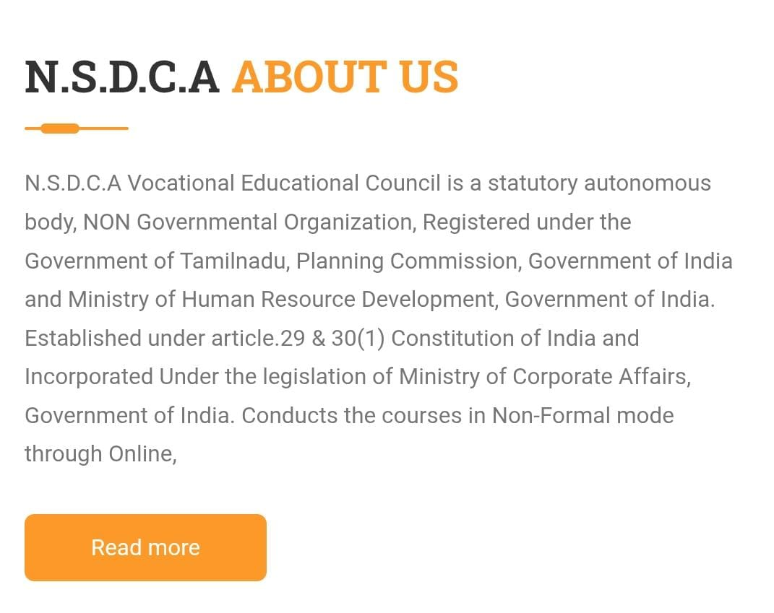
* Vision & Mission
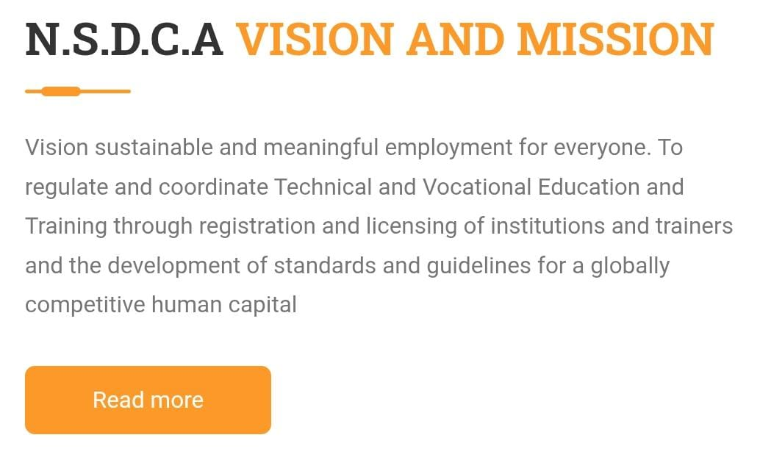
VISION:
1. Studying development trends in the labour market and preparation of occupation profiles as well as competently conceived occupational standards.
2. Development of methodologies and preparation of modern, module-based education programmes for vocational education
3. Monitoring the process of the introduction of education programmes, evaluation of final examinations and vocational education and development of new methodical and didactical concepts of knowledge, learning and teaching,
4. Training and improvement of knowledge of teachers, professionals and mentors in the framework of vocational and technical education, and provision of professional support and counselling to providers of vocational and technical education
5. Stimulation and coordination of various development and innovation projects in vocational and technical schools
6. Development of modern education tools and education technology,
7. Participation in professional organisations networks dealing with vocational and technical education.
8. Promotion and encouragement of vocational education.

MISSION:
1. To develop strategic and simplified texts in the field of formal and informal education,
2. To become the reference point for International and National Networks
3. To establish and run an educational and consulting centre for further education and training of educators in the field of vocational education and training based on the principles of lifelong learning
4. To establish and run a national centre where informal knowledge is to be ascertained and acknowledged
5. To establish and run a national centre where the level of quality in the system of vocational and technical education as well as training is to be ascertained and assured for the development of the students.
6. To establish a network designed to develop and promote vocational education

* Organization Chart.
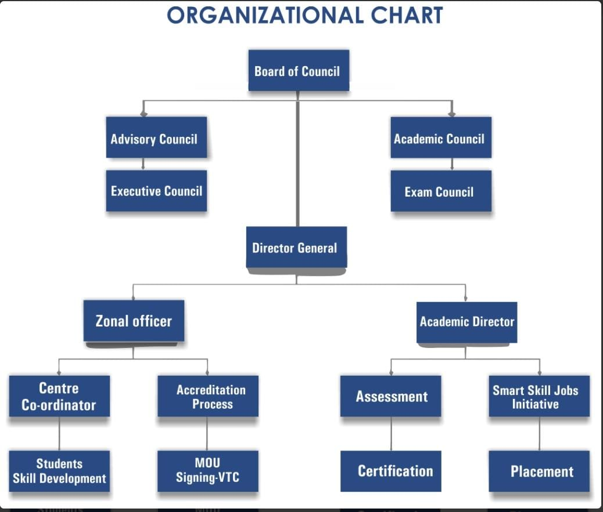
* Branches
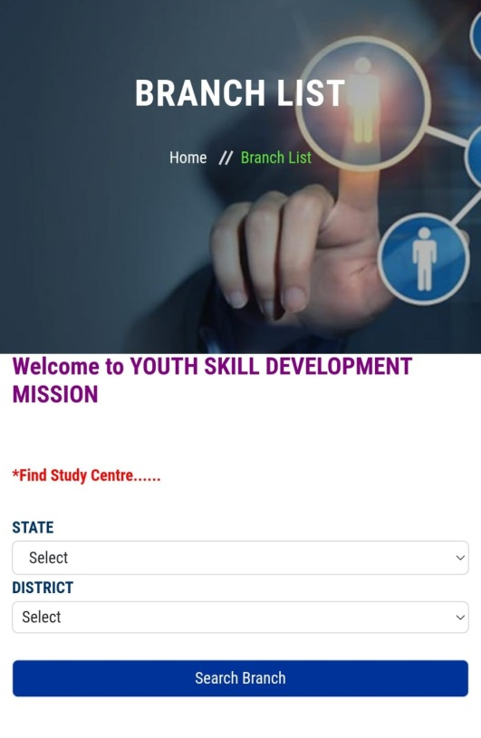
* Director Message
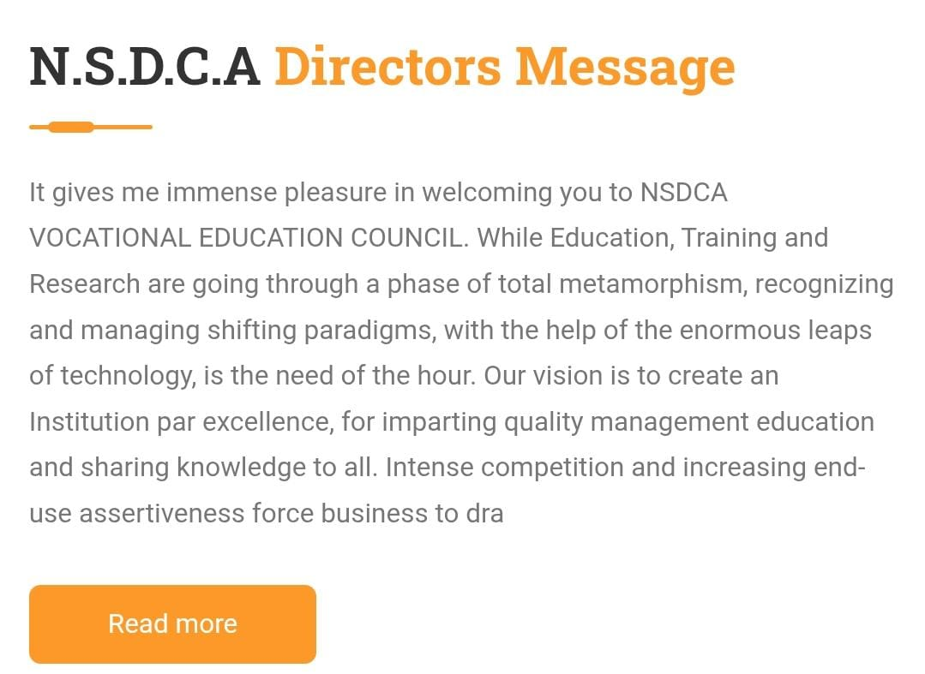

It gives me great pleasure to welcome you to “Navigating Career for Vocational Skill Technology Council”.
India is a resource of massive manpower and for the development of our country using this resource , NCVSTC leads the race by taking a proactive step to converge a wave of skill development in India by giving recognized certified training with present market relevant skills. The advantage of skill development wherein the implementation of such schemes will make a strong impact in empowering socio-economic status, mitigate poverty, reduce social challenges, and economic inclusion.
Candidate joining these vocational courses will get an idea to find and sculpt there hidden inner talent, which will make their responsible character recognized in the society and will make them stand on their own feet and altogether will increase the work force of our country by making the livelihood of the millions of Indians.
NCVSTC aims to catalyze skilling initiatives that can have a good impact in the economy and skill development. The quality team at NCVRT focuses on enabling standardized structure to enhance the skill development across the country. All skill training programs adheres to the National Standards. To assure consistency and quality of skilling across the training initiatives for various jobs across the country, NCVSTC coordinates and leads many VTCs .NCVSTC evaluate the performance of skill development programs in different VTCs, to foster excellence and build effectiveness in training which enables the trainees to make informed choices regarding Training Centers.
I would like to congratulate the candidate who had joined NCVSTC courses and who had made a positive mind to join. Along with improvising the education, we have also worked on the entire process, starting from admission till getting the certificate. I encourage the students to get enrolled in different courses, and also get participated in various events organized by NCVSTC at regular interval of time. NCVSTC will provide quality training and will play a vital role in professional skills development.
* Office
- State Programme Office (SPO)
- District Regional Office (DRO)
- Zonal Offices

  - State Programme Office (SPO)

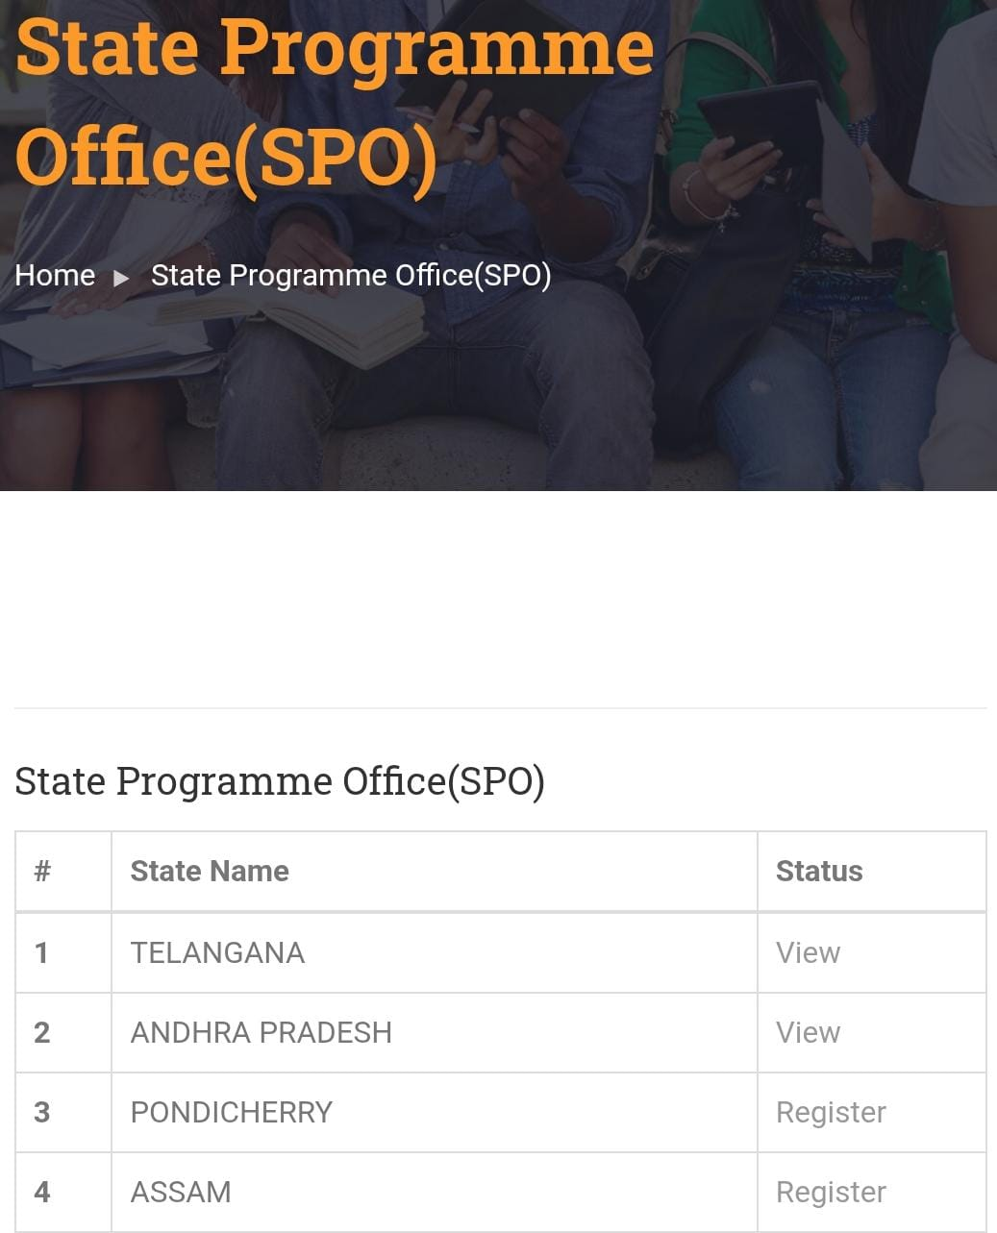
  - District Regional Office (DRO)

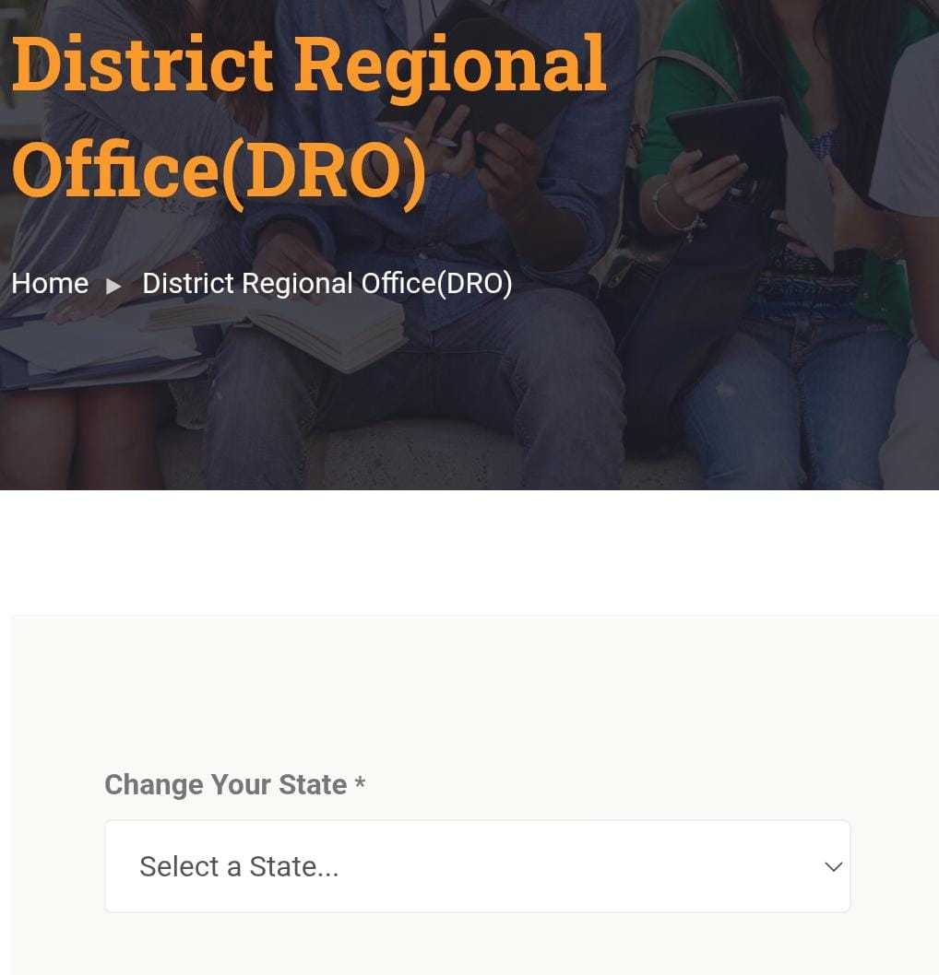

  - Zonal Offices
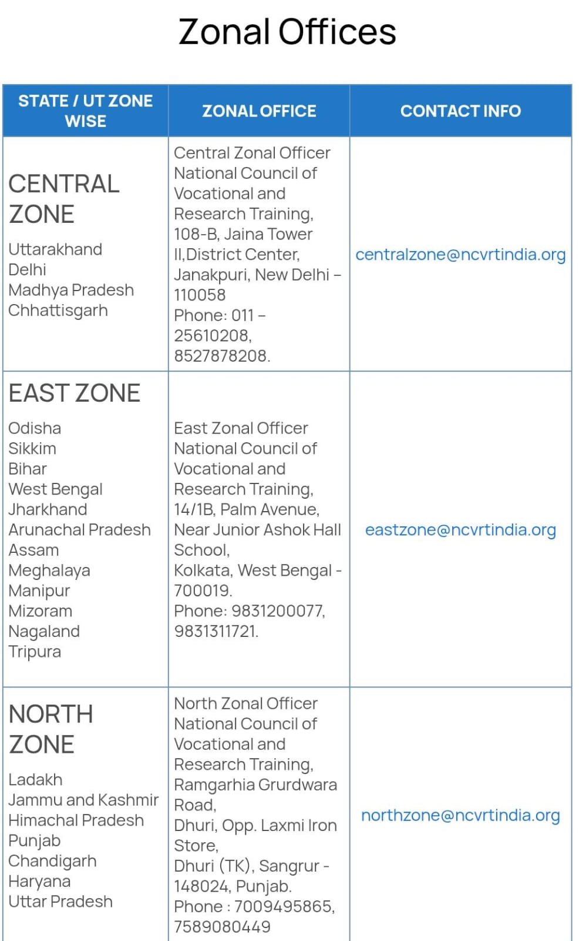

- Our Service & Function
- Courses
- Government Project
- Career and Placement
- Certificate of Organization

* Courses
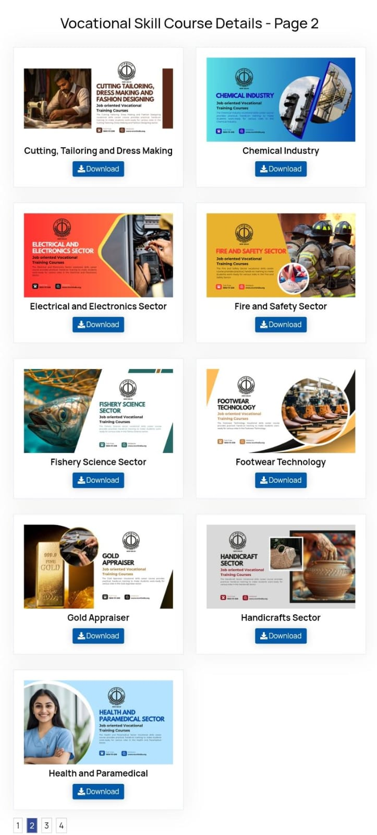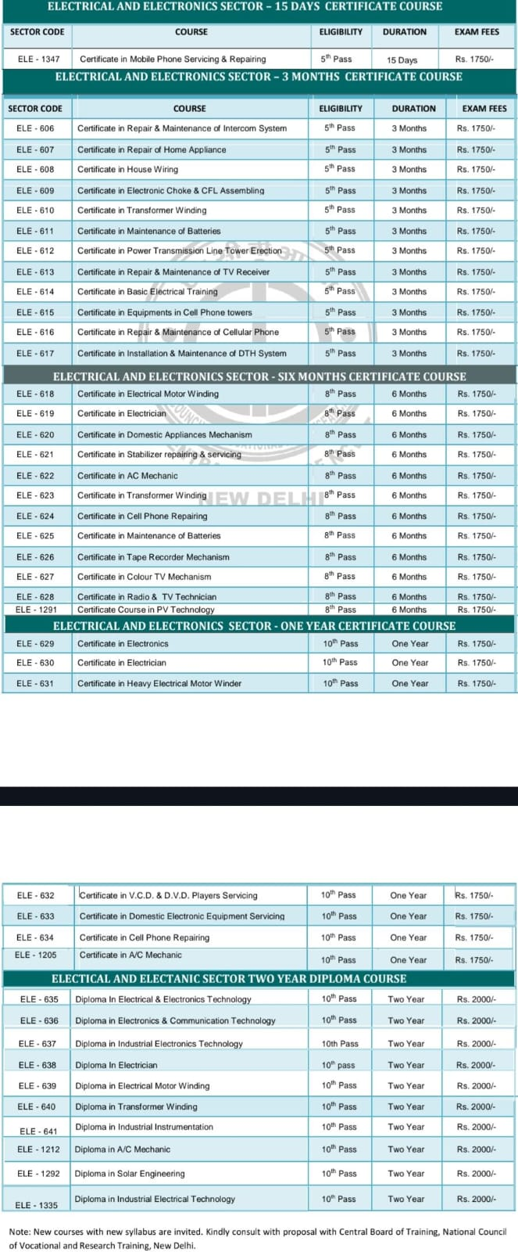

* Government Project

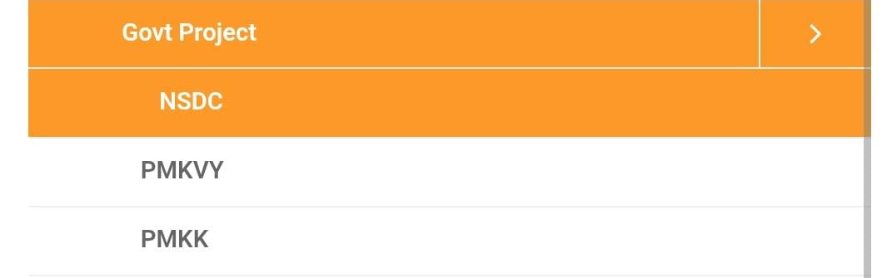

* Career and Placement
The Career & Placement Cell is responsible for organizing various qualitative training sessions in campus as per the requirements of the students & industry to equip students with the skill set to make them employable in the job market. The training sessions on soft skills, Corporate Grooming, Etiquettes & various career guidance session are aiming to Effectively bridge the gap between classroom learning and corporate business expectations of the recruiters.
Objective:
To develop recruitment strategies that will attract professional supporters in leading institutions for the purpose of building a coalition of professional support.
The purpose of this cell is counseling students and providing employment-readiness services that will meet the demands of a highly skilled workforce, thus creating interest and professionalism in the students
The assistance offered is as follows:
Students are provided Career Guidance and Placement Preparation Sessions.
Students are assigned interviews with prospective employers based on their skill levels, aptitude and career aspirations.
The Cell liaisons with the prospective hiring organization till the actual placement takes place. It negotiates on behalf of the prospective employee with the industry for the best terms and conditions.
ENTREPRENEURSHIP DEVELOPMENT CELL:
Entrepreneurship Development Clubs is to sensitize the student community about the need and importance of industrialization. For this there is a need for developing an entrepreneurial culture which involve a set of values, norms and traits that are conducive to the growth of Entrepreneurship.
The other objectives include:
Teaching them the way of earning income while learning,
The methodology of preparation of project report,
The various incentive schemes offered by industries department,
Helping the student community in identifying projects of viable nature,
The way of getting financial assistance from banks / Financial Institutions.
Arranging platform for interacting with successful entrepreneurs to build confidence.
Developing in them an entrepreneurial culture. sector has not been developed much
The main functions to be carried out by the Entrepreneurship Development Clubs are:
Organize interactive sessions with successful entrepreneurs for sharing the success stories.
Organize entrepreneurship awareness programmes and entrepreneurship clinics for giving information about project preparation, steps in organizing industries, incentives and schemes available, manner of obtaining bank finance, areas open to new generation entrepreneurs and importance of the feasibility study.
Organic industrial visits and interaction with promotional agencies.
Activities of the Career Guidance and Placement Cell- N.C.V.S.T.C:
Sustained training for placements and competitive examinations across six semesters
Knowledge building sessions
Training in basic communication skills
Training in group discussion and interview skills
Aptitude Test training
Excel training
Career Guidance sessions from industry experts helping students to make informed choices regarding their careers.
Skill for Education and Employability Council
It is envisaged that professionally qualified graduates with a sound knowledge of their core disciplines and expertise in a concerned skill will have more openings in service, industry and self-employment sectors. The objective of the Programme is to introduce career and market-oriented, skill enhancing add-on Courses that have utility for job, self-employment and empowerment of the students. At the end of three years, the students will be equipped with a Certificate/Diploma/Advanced diploma in an add-on orientation course along with a conventional degree in Science/Arts/Commerce. College offers Add on Courses in three departments under UGC scheme and one DCA Course.

*Certificate of Organization
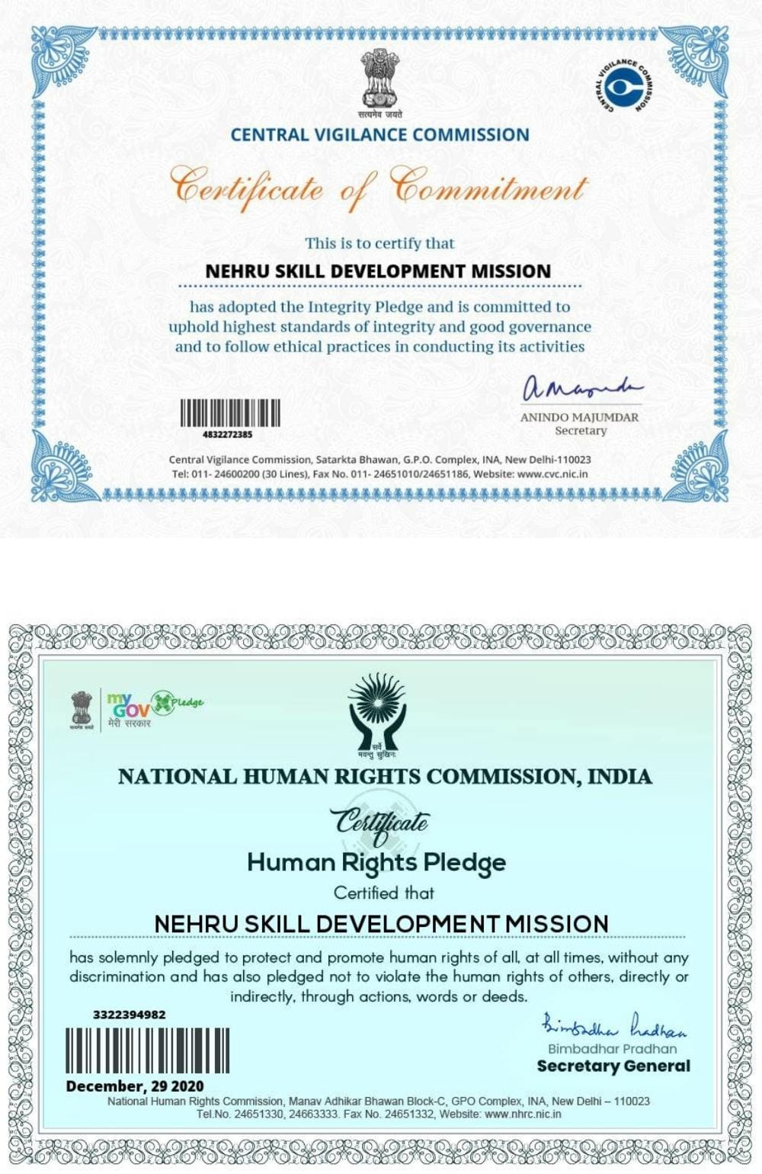

- Programs & Government Initiatives
- Student Development Schemes
- Institutional Development Schemes
- Staff Development Schemes
- Vocational Education Initiatives
- Community College Initiatives
- Skill Development Initiatives

* Student Development Schemes
The NCVSTC Vocational Education Council is established for development of education under the guidelines of national education policy 1986 and programme of action 1992 Govt. of India respectively.
It has been constituted to regulate non formal Primary, Middle, Matriculation (10th), Senior Secondary (12th) education and other vocational courses (Under Self Employment Education Scheme) in India. With the help of educational experts to educate uneducated boys, girls, men and women for upliftment of the literacy in India. So that they can serve society effectively and with dignity. Board may impart education with international techniques and with stress on moral, mental, physical and social personality.
Like all educational boards/Universities ours is also an autonomous body. Each educational organization acts on its own discretionary powers. According to these powers every board / university / state Govts. / Central Govt. of India has the liberty and right to take its own decision either to allow or refuse any admission / service. But we do our best to make success the non formal education programme. All the education programme run by the board is board's own autonomous education programme. Legality, Validity, Utility of the education programme is strict conformity with the constitution of India and law of the land under Article 19(1)G, 29 & 30.
Recognition of Degree/Diploma by Govt. of India
NOTIFICATION NO. P 26/4/52 C.C.
GOVERNMENT OF INDIA
Ministry of Home Affairs
New Delhi
Dated : 20th September, 1952
Subject: Recognition of the Examination
According to Ministry of the Home Affairs Government of India. Notification No. 26/4/52 C.C. Dated 20/09/52 issued in consultation with the Union Public Service Commission, that in case of Degree/Diploma awarded by Board & University in India which are in corporate by one Act of Central or part & State Legislature in India. No formal orders. Recognized automatically for the purpose of employment.
Harish Chandra
Under Secretary Government of India
Under Human Rights Protection Act 1993, autonomous body have been given special protection and consideration. According to J.P. Unnikrishnan Vs Govt. of Andhra Pradesh AIR 1993 Supreme Court 2178 verdict voluntary organization like Trusts, Societies etc. have right to spread education and issue Certificates for Degrees/Diplomas Courses.
The NCVSTC /Council Director/members has the constitutional right under Article 19 (1) (g) to pursue any profession or any occupation and running teaching institutes have been included as part of occupation as held by Hon'ble Supreme Court in T.M.A. Pai Foundation Vs. State of Karnataka (SC) 2003 (2) SCT 385. The relevant portion of the above said judgment is reproduced as under:-
Private education is one of the most dynamic and fastest growing segments of post-secondary education at the turn of the twenty –first century. A combination of unprecedented demand for access to higher education and the inability or unwillingness of government to provide the necessary support has brought private higher education to the forefront. Private institutions with a long history in many countries, are expanding in scope and number, and are becoming increasingly important in parts of the world that relied almost entirely on the public sector.
Under HUMAN RIGHTS PROTECTION ACT ,1993 autonomous bodies have been given special protection & consideration.( For further details refer: AIR 1993 SC-2178.
Features:
•Our motto is Education, Health & Character.
• To give the best possible teaching and training to its students. So they can serve society effectively and with dignity.
• Democratizing higher education by taking it to the doorsteps of learners.
• Providing assess to high quality to all those who seek it irrespective of age, region or formal qualifications.
• Offering need based academic programmers by giving professional and vocational orientation to the course.
• To promoting and developing distance education in India & Abroad.
• To individualized study: - flexibility in terms of place and duration of study
• To give cost effective and self-employment education programme.
• Student support through the services network.
EXAMINATION
The final examination in theory and practical are held at the end of the academy year session in March/ April and in supplementary exams in Calendar year September/October. A candidate has declared successful on scoring minimum of 50-% marks in each paper. As per rule 3b-9.
CERTIFICATION
Every successful declared student will be awarded Diploma/Degree Certificate by the NCVSTC Vocational Educational Council in each education programme. As per rule 3b-9.
AGE& SEX
There will be no restriction of age, caste, sex, region, country under skill development programme, vocational education, and distance education system of the board.
MEDIUM
The medium of each education programme will be according to their Regional Language/ State Language/ Country Language. But Question Paper Will be published only in English / Hindi, student can give answer in english/ hindi or his/ her state language. But it should be mentioned earlier in the examination form.
ATTESTATION OF CERTIFICATES
The Certificates of the NCVSTC Vocational Education Council get Attestation from Foreign Embassies for Education and Employment purposes. Being a NON-UGC Programme, the Certificates of the NCVSTC are not recommended for PSC/UPSC Appointments. It is widely used in Public Sector Undertakings, Multi-National Companies and Private Sector in India and abroad who are satisfied with the Official Verification System.

RULES & REGULATIONS

Check and satisfy necessary information about education programme / board before admission no responsibility of the institute / board after that.
Fees once paid should not be refunded or changed under any rule.
Every student abides to and obtains to present rule and regulations and directions of the institute/ board and also those which are to be enforced time to time.
Any change of the rules & regulation directions by the exam body shall be acceptable to the student.
The Board / organization run non-formal self-employment education programme only and not give any guarantee for further educational use or any job.
If any document found bogus the admission and result should be canceled automatically without any notice.
If student fails to deposit the fees in the due time the admission should be canceled without any notice and any primary deposit fees should not be refunded.
If study material or documents will be lost in the post no responsible of the institute / board.
If any student / members / teachers / employees of any institute / center have any dispute with the board / institution it will be resolved through the committee appointed by the NCVSTC Vocational Education Council under Indian Arbitration Act 1940. The decision of the arbitrator shall be final and binding on all parties, Direct Court will not be permissible.

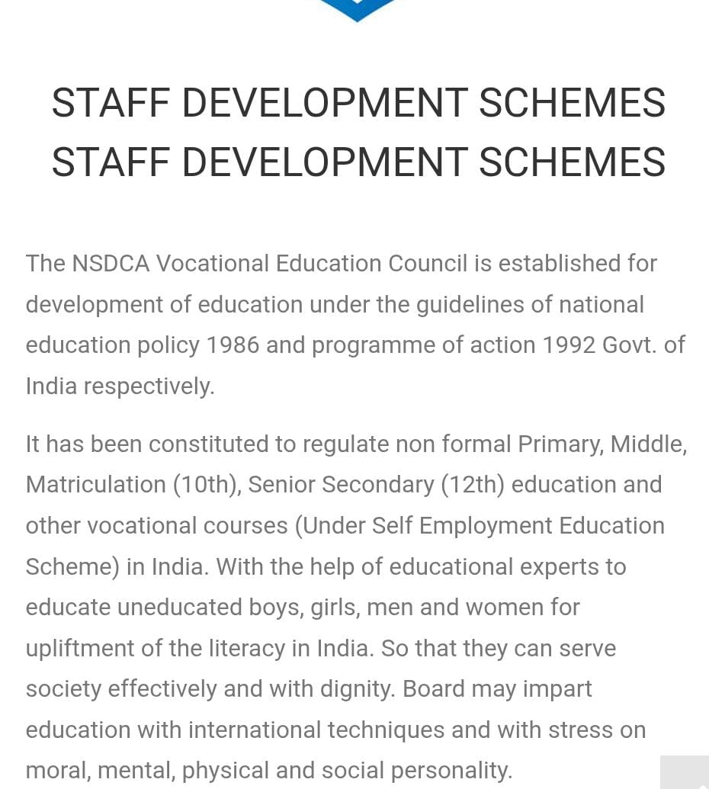

* Institutional Development Schemes
MISSION
We ensure the success of all students by offering relevant and innovative career technical education to employment opportunities. To be a leading Authority in the regulation, quality assurance and accreditation of technical and vocational and training for the provision of Competent of human capital.
VISION
Vison sustainable and meaningful employment for everyone.
To regulate and coordinate Technical and Vocational Education and Training through registration and licensing of institutions and trainers and the development of standards and guidelines for a globally competitive human capital
AIM
With its world-class vocational training institutes (NCVSTC”S) education is setting a benchmark in skill development .the aim is to offer skill-specific training that will help students find excellent job opportunities in the global workspace.
OBJECTIVE
To ensuring quality of education and training
To prepare ground for level based training system and encourage sustainable development that will create an economic viability for present and future generations.
OUR VALUES
Integrity - We treat our customers and staff ethically, fairly, and honestly.
Teamwork - We celebrate and capitalize on the strengths and contributions of others.
Service - We provide premier customer service.
Creativity - New ideas stimulate discovery and foster innovation, leading to more effective learning.
Learning - We cultivate lifelong learning.
Excellence - We embody the highest level of excellence.
Accountability - We take responsibility for our actions and empower others to do so as well.
Respect - Our learning environment embraces and fosters diversity among people and ideas.
SCOPE
Technology is touching every aspect of life and society. So, there is a dire need of backing up conventional study and teaching with technical education, as it will not only help in the development of the country, but also the person possessing those skills. A technically sound person is never short of jobs. Thus, technical education as per the needs of the present market will assist in uplifting society. In India, overall education can be divided into social, spiritual and vocational. Concerns related to society are covered under social education, personality development is the part of spiritual education and vocational education consists of technical education that further deals with branches like agriculture, medicine, engineering and commerce. Technical education is a skill-based education that primarily keeps the job prospects in mind. It provides training to the individual in a specific field
To overcome these hurdles, old curriculum must be updated with a new and advanced one. Also, new institutes must be set in to provide advance information regarding this field. Classes should be more interesting and interactive with full industry participation. Students must be made aware of their growth path in the selected stream.
It is not that our education system is full of flaws. We have a rich educational heritage and a very strong primary education system. Subject knowledge is extensively given in India, and Indians have vast theoretical knowledge as well. As compared to developed countries, India has a good number of higher educational institutions. But on the other hand, lack of an updated curriculum and specialized technical education are the flaws in our education system.
OUR GOAL
We intend to provide a comprehensive, highly economic and people friendly vocational training system.
1.To develop a comprehensive, flexible and responsive Vocational Training System.
2.To increase the access to formal and non-formal Vocational Training Programme.
3.To widen the scope of work education and life skills.
4.To accredit courses and institutions providing vocational education and training.
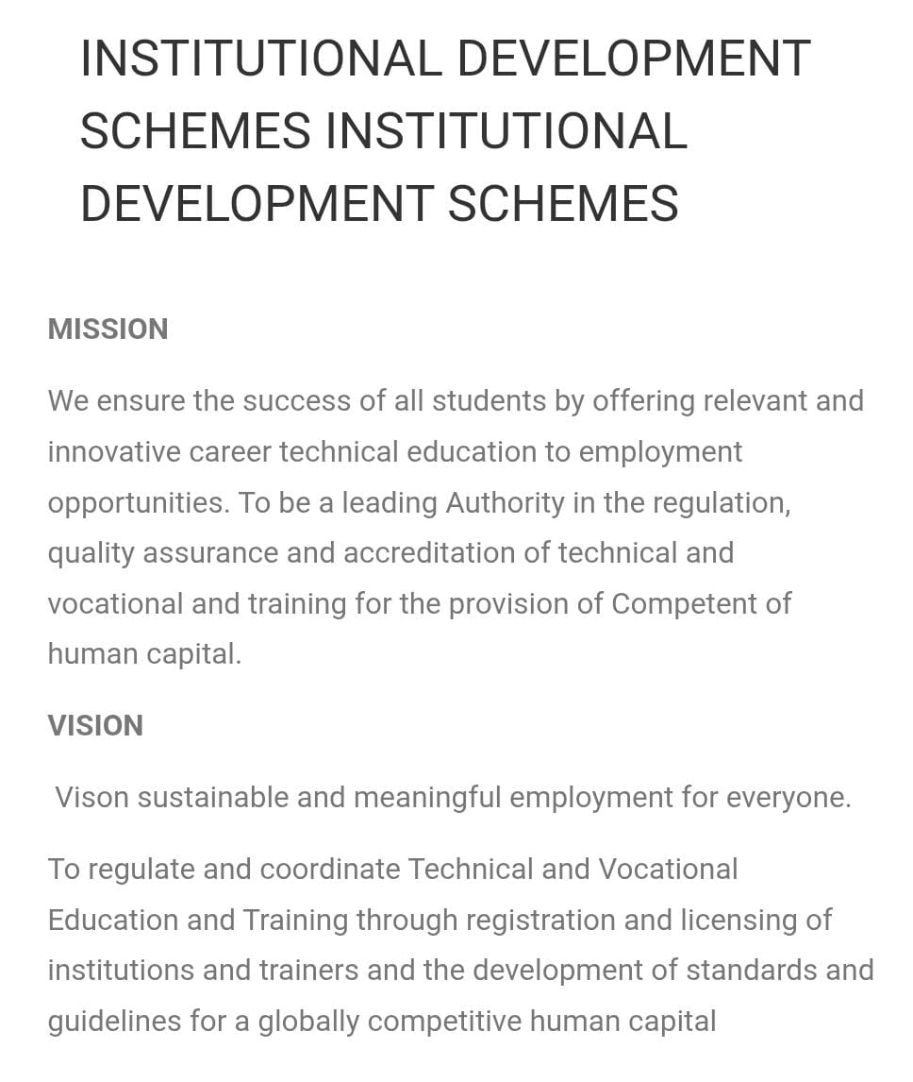
* Staff Development Schemes
The NCVSTC Vocational Education Council is established for development of education under the guidelines of national education policy 1986 and programme of action 1992 Govt. of India respectively.
It has been constituted to regulate non formal Primary, Middle, Matriculation (10th), Senior Secondary (12th) education and other vocational courses (Under Self Employment Education Scheme) in India. With the help of educational experts to educate uneducated boys, girls, men and women for upliftment of the literacy in India. So that they can serve society effectively and with dignity. Board may impart education with international techniques and with stress on moral, mental, physical and social personality.
Like all educational boards/Universities ours is also an autonomous body. Each educational organization acts on its own discretionary powers. According to these powers every board / university / state Govts. / Central Govt. of India has the liberty and right to take its own decision either to allow or refuse any admission / service. But we do our best to make success the non formal education programme. All the education programme run by the board is board's own autonomous education programme. Legality, Validity, Utility of the education programme is strict conformity with the constitution of India and law of the land under Article 19(1)G, 29 & 30.
Recognition of Degree/Diploma by Govt. of India
NOTIFICATION NO. P 26/4/52 C.C.
GOVERNMENT OF INDIA
Ministry of Home Affairs
New Delhi
Dated : 20th September, 1952
Subject: Recognition of the Examination
According to Ministry of the Home Affairs Government of India. Notification No. 26/4/52 C.C. Dated 20/09/52 issued in consultation with the Union Public Service Commission, that in case of Degree/Diploma awarded by Board & University in India which are in corporate by one Act of Central or part & State Legislature in India. No formal orders. Recognized automatically for the purpose of employment.
Harish Chandra
Under Secretary Government of India
Under Human Rights Protection Act 1993, autonomous body have been given special protection and consideration. According to J.P. Unnikrishnan Vs Govt. of Andhra Pradesh AIR 1993 Supreme Court 2178 verdict voluntary organization like Trusts, Societies etc. have right to spread education and issue Certificates for Degrees/Diplomas Courses.
The NCVSTC /Council Director/members has the constitutional right under Article 19 (1) (g) to pursue any profession or any occupation and running teaching institutes have been included as part of occupation as held by Hon'ble Supreme Court in T.M.A. Pai Foundation Vs. State of Karnataka (SC) 2003 (2) SCT 385. The relevant portion of the above said judgment is reproduced as under:-
Private education is one of the most dynamic and fastest growing segments of post-secondary education at the turn of the twenty –first century. A combination of unprecedented demand for access to higher education and the inability or unwillingness of government to provide the necessary support has brought private higher education to the forefront. Private institutions with a long history in many countries, are expanding in scope and number, and are becoming increasingly important in parts of the world that relied almost entirely on the public sector.
Under HUMAN RIGHTS PROTECTION ACT, 1993 autonomous bodies have been given special protection & consideration. ( For further details refer: AIR 1993 SC-2178).
Features:
• Our motto is Education, Health & Character.
• To give the best possible teaching and training to its students. So they can serve society effectively and with dignity.
• Democratizing higher education by taking it to the doorsteps of learners.
• Providing assess to high quality to all those who seek it irrespective of age, region or formal qualifications.
• Offering need based academic programmers by giving professional and vocational orientation to the course.
• To promoting and developing distance education in India & Abroad.
• To individualized study: - flexibility in terms of place and duration of study
• To give cost effective and self-employment education programme.
• Student support through the services network.
EXAMINATION
The final examination in theory and practical are held at the end of the academy year session in March/ April and in supplementary exams in Calendar year September/October. A candidate has declared successful on scoring minimum of 50-% marks in each paper. As per rule 3b-9.
CERTIFICATION
Every successful declared student will be awarded Diploma/Degree Certificate by the NCVSTC Vocational Educational Council in each education programme. As per rule 3b-9.
AGE& SEX
There will be no restriction of age, caste, sex, region, country under skill development programme, vocational education, and distance education system of the board.
MEDIUM
The medium of each education programme will be according to their Regional Language/ State Language/ Country Language. But Question Paper Will be published only in English / Hindi, student can give answer in english/ hindi or his/ her state language. But it should be mentioned earlier in the examination form.
ATTESTATION OF CERTIFICATES
The Certificates of the NCVSTC Vocational Education Council get Attestation from Foreign Embassies for Education and Employment purposes. Being a NON-UGC Programme, the Certificates of NCVSTC are not recommended for PSC/UPSC Appointments. It is widely used in Public Sector Undertakings, Multi-National Companies and Private Sector in India and abroad who are satisfied with the Official Verification System.

RULES & REGULATIONS
Check and satisfy necessary information about education programme / board before admission no responsibility of the institute / board after that.
Fees once paid should not be refunded or changed under any rule.
Every student abides to and obtains to present rule and regulations and directions of the institute/ board and also those which are to be enforced time to time.
Any change of the rules & regulation directions by the exam body shall be acceptable to the student.
The Board / organization run non-formal self-employment education programme only and not give any guarantee for further educational use or any job.
If any document found bogus the admission and result should be canceled automatically without any notice.
If student fails to deposit the fees in the due time the admission should be canceled without any notice and any primary deposit fees should not be refunded.
If study material or documents will be lost in the post no responsible of the institute / board.
If any student / members / teachers / employees of any institute / center have any dispute with the board / institution it will be resolved through the committee appointed by the NCVSTC Vocational Education Council under Indian Arbitration Act 1940. The decision of the arbitrator shall be final and binding on all parties, Direct Court will not be permissible.
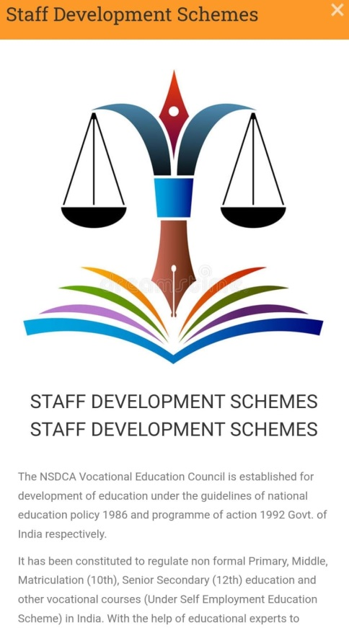

* Vocational Education Initiatives
NCVSTC STATUTORY COMMITTEES
1. Establishment of Anti Ragging Committee:-
(As per NCVSTC VOCATIONAL EDUCATION notified regulation for prevention and prohibition of ragging in NCVSTC approved Skill/Vocational Institutions)
Objective:
Prevention and prohibition of Ragging in Skill/Vocational Institutions, Community College including set up VTP’S/STP,S imparting Skill /Vocational education.
ASSOCIATED ACTIVITIES:
ANTI-RAGGING COMMITTEE
Every Institution community college including set up VTP’S/STP’S imparting Skill /Vocational /technical education shall constitute a Committee to be known as the Anti-ragging Committee to be nominated and headed by the Head of the Institution, and consisting of representatives of civil and police administration, local media, Non-Government Organizations involved in youth activities, representatives of faculty members, representatives of parents, representatives of students belonging to the fresher’s category as well as senior students, non-teaching staff; and shall have a diverse mix of membership in terms of level as well as gender.
ANTI-RAGGING SQUAD
Every Institution/ community college including set up VTP’S/STP’S imparting Skill /Vocational /technical education also constitute a smaller body to be known as the Anti-Ragging Squad to be nominated by the Head of the Institution with such representation as may be considered necessary for maintaining vigil, oversight and patrolling functions and shall remain mobile, alert and active at all times. Provided that the Anti-Ragging Squad shall have representation of various members of the campus community and shall have no outside representation.

2. Establishment of Grievance Redressal Committee
Objective:
In order to ensure transparency by Institution/ community college including set up VTP’S/STP’S imparting Skill /Vocational /technical education, in admissions and with Paramount Objective of preventing unfair practices and to provide a mechanism to innocent students for redressal of their grievances.
ASSOCIATED ACTIVITIES:
Each Institution/ community college including set up VTP’S/STP’S shall establish a registry, headed by an employee of the institute of appropriate rank as the NCVSTC Council may decide, where an aggrieved student or person may make an applicant seeking redressal of grievance.
The address of the registry so established shall be published widely including on the notice board and prospectus and placed on the website of the institution.

3. Internal Complaint Committee (ICC)
(As per section 4 of Sexual Harassment of Women at Workplace (Prevention, Prohibition and Redressal) Act, 2013)
Objective:
Prevention, prohibition and redressal of sexual harassment of women employees and students in higher educational institutions.
ASSOCIATED ACTIVITIES:
Internal Complaints Committee (ICC) to be constituted by an Skill and Vocational Education Institute shall ensure that the constitution of such a Body is as required for ICC under these regulations. Provided further that such a Body shall be bound by the provisions of these regulations.
Publicly notify and commit itself to a zero tolerance policy towards sexual harassment by organise training programmes or as the case may be, workshops for the officers, functionaries, faculty and students
4. Committee for SC/ST
(As per the Scheduled Castes and the Scheduled Tribes (prevention of Atrocities) act, 1989, No. 33 of 1989, dated 11.09.1989)
Objective:
The Scheduled Caste (SC) and Scheduled Tribes (ST) Cell in an institute promotes the special interests of students in the reserved category. It is expected to provide special inputs in areas where the students experience difficulties.
ASSOCIATED ACTIVITIES:
The Cell may conduct regular remedial coaching classes on life skills, personality development, writing assignments and making presentations, as well as English and local language classes. The Cell also is expected to organize interactive sessions and informal meetings with students to attend to their personal, social and academic problems.
Guide the SC/ST/OBC/PWD students of the Institute, to optimally utilize the benefits of the schemes offered by the State Governments, Government of India (GOI) and UGC.

OTHER STATUTORY COMMITTEES
(1) Governing Council
(2) Finance Committee
Objective:
To satisfy the financial requirements of the Institution.

ASSOCIATED ACTIVITIES:
The Governing Body shall arrange to have the college accounts audited by the end pf each financial year by a Chartered Accountant. The annual accounts and audit report of the college shall be made available to the University and to the Government for inspection whenever applicable. Annual general body meeting of the registered society / trust as applicable shall be convened regularly.

(3) Purchase Committee
Objective:
Monitoring & Documenting Purchase related activities.
(4) Welfare Committee
Objective:
To monitor and meet the academic and welfare activities of student / staff
ASSOCIATED ACTIVITIES:
The academic and welfare activities of students belonging to SC/ST/BC physically challenged, women and other weaker sections are properly looked into and special attention should be taken.
Co / Extra Curricular & Extension activities are conducted to the students.
Facilities to staff members.

(5) Mentoring / Counselling Cell
Objective:
Young adults nowadays are faced with a number of issues related to academics and otherwise during their student life. They are in need of an outlet to express their emotional upheavals. This is where a student counselor comes into picture. We have a regular counselor. The most common issues faced by students are related to time management, stress management, peer pressure, procrastination, body language, communication skills etc. One-to-one counseling sessions with the student counselor helps our students to sort out these issues and unburden themselves of their problems.

ASSOCIATED ACTIVITIES:
By making the sessions light and interactive, the student counselor creates a conducive environment for the students to facilitate effective communication. Counseling helps the students concentrate better on their studies without getting emotionally drained by other issues.
(6) Women Empowerment Cell
Objective:
To empower women students and staff to make them understand and react suitable to the issues pertaining to women students.
ASSOCIATED ACTIVITIES:
1.To sensitize the college community on the need for empowerment of women
2.To counsel women boarders and non-resident women students
3.To enable the College community understand the role of everyone in
empowering women students

NCVSTC NON-STATUTORY COMMITTEES

(1) External Relations
Objective:
A director of external relations is a communications manager tasked with creating a positive public image for an Institution. This type of public relations job requires an expert communicator with extensive experience in handling situations.
ACTIVITIES ASSOCIATED:
Directors may do this by overseeing the writing and editing of event scripts, speeches, shareholder documents and reports, advertising and promotional materials, press releases, interviews, and any other external communications.
In the case of an unforeseen issue, crisis or other potentially problematic situation, the director of public relations generates communications to maintain a positive image for the Institute.

(2) R&D Activities
Objective:
The Research and Development Cell aims to nurture research culture in the College by promoting research in newly emerging and challenging areas of Engineering, Technology, Science and Humanities.
ASSOCIATED ACTIVITIES:
1.To encourage faculty members of all the disciplines in Engineering/Science /Humanities in R&D activities for their professional growth.
2.To undertake research activities and development projects offered by agencies such as ISRO, DRDO, CSIR, DST, AICTE, UGC, DBT, INFOSYS, etc.
3.To encourage staff members and students to publish technical papers for publishing in National and reputed International Conferences/Journals
(3) Student Extra Curricular Activities
Objective:
To motivate the students and coordinating them to carry out extra-curricular activities through various departmental clubs and other clubs in the college.

ASSOCIATED ACTIVITIES:
1.Establishment of Departmental Clubs
2.Planning of activities through the established clubs
3.Executing the events planned through various clubs

(4) Hostel Committee
Objective:
To frame and monitor the rules and regulations of the Hostel and ensuring the proper conduction.
ASSOCIATED ACTIVITIES:
A certain measure of self-governing, decision-making and problem solving is involved in the hostel administration. This aspect of the college hostel life promotes the students' sense of responsibility and sensitive self-awareness. Hostel students are expected to adhere to the rule.
(5) Library Advisory Committee
Objective:
To enhance the library facilities on timely basis and upgrading the library as per the updated regulations.
ASSOCIATED ACTIVITIES:
1.To frame general rules for the management of the Library
2.To advise the Librarian regarding general library development
3.To prepare the annual budget estimates
4. To arrange for the stock taking of the library

(6) Academic Audit
Objective:
To monitor the academic related activities and maintains the documentation related to various Departments.
ASSOCIATED ACTIVITES:
Monitoring the academic activities of the Departments
Academic document verification on timely basis
Consolidation of academic data
(7) Examination Committee
Objective:
To coordinate with the University for the proper conduction of final semester exams and also taking role in the conduction of Internal Assessment Tests.
ASSOCIATED ACTIVITIES:
Conduction of Internal Assessment Tests
Framing a committee and work towards the conduction of University Exams
(8) Admission Committee
Objective:
To coordinate with the Government and University to carry out the government admissions for the respective academic years
To effectively carry out the admission process for Management Quota.
ASSOCIATED ACTIVITIES:
Admission procedure as per the regulations framed by the Government / University

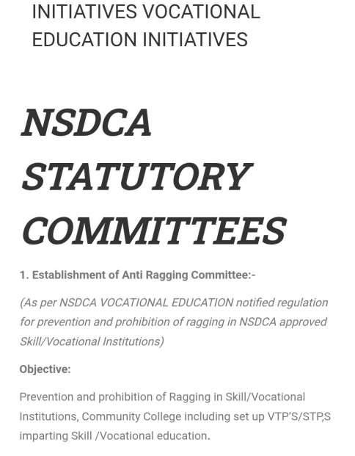

* Community College Initiatives
The NCVSTC Vocational Education Council is established for development of education under the guidelines of national education policy 1986 and programme of action 1992 Govt. of India respectively.
It has been constituted to regulate non formal Primary, Middle, Matriculation (10th), Senior Secondary (12th) education and other vocational courses (Under Self Employment Education Scheme) in India. With the help of educational experts to educate uneducated boys, girls, men and women for upliftment of the literacy in India. So that they can serve society effectively and with dignity. Board may impart education with international techniques and with stress on moral, mental, physical and social personality.
Like all educational boards/Universities ours is also an autonomous body. Each educational organization acts on its own discretionary powers. According to these powers every board / university / state Govts. / Central Govt. of India has the liberty and right to take its own decision either to allow or refuse any admission / service. But we do our best to make success the non formal education programme. All the education programme run by the board is board's own autonomous education programme. Legality, Validity, Utility of the education programme is strict conformity with the constitution of India and law of the land under Article 19(1)G, 29 & 30.
Recognition of Degree/Diploma by Govt. of India
NOTIFICATION NO. P 26/4/52 C.C.
GOVERNMENT OF INDIA
Ministry of Home Affairs
New Delhi
Dated : 20th September, 1952
Subject: Recognition of the Examination
According to Ministry of the Home Affairs Government of India. Notification No. 26/4/52 C.C. Dated 20/09/52 issued in consultation with the Union Public Service Commission, that in case of Degree/Diploma awarded by Board & University in India which are in corporate by one Act of Central or part & State Legislature in India. No formal orders. Recognized automatically for the purpose of employment.
Harish Chandra
Under Secretary Government of India
Under Human Rights Protection Act 1993, autonomous body have been given special protection and consideration. According to J.P. Unnikrishnan Vs Govt. of Andhra Pradesh AIR 1993 Supreme Court 2178 verdict voluntary organization like Trusts, Societies etc. have right to spread education and issue Certificates for Degrees/Diplomas Courses.
The NCVSTC /Council Director/members has the constitutional right under Article 19 (1) (g) to pursue any profession or any occupation and running teaching institutes have been included as part of occupation as held by Hon'ble Supreme Court in T.M.A. Pai Foundation Vs. State of Karnataka (SC) 2003 (2) SCT 385. The relevant portion of the above said judgment is reproduced as under:-
Private education is one of the most dynamic and fastest growing segments of post-secondary education at the turn of the twenty –first century. A combination of unprecedented demand for access to higher education and the inability or unwillingness of government to provide the necessary support has brought private higher education to the forefront. Private institutions with a long history in many countries, are expanding in scope and number, and are becoming increasingly important in parts of the world that relied almost entirely on the public sector.
Under HUMAN RIGHTS PROTECTION ACT ,1993 autonomous bodies have been given special protection & consideration.( For further details refer: AIR 1993 SC-2178.
Features:
• Our motto is Education, Health & Character.
• To give the best possible teaching and training to its students. So they can serve society effectively and with dignity.
• Democratizing higher education by taking it to the doorsteps of learners.
• Providing assess to high quality to all those who seek it irrespective of age, region or formal qualifications.
• Offering need based academic programmers by giving professional and vocational orientation to the course.
• To promoting and developing distance education in India & Abroad.
• To individualized study: - flexibility in terms of place and duration of study
• To give cost effective and self-employment education programme.
• Student support through the services network.
EXAMINATION
The final examination in theory and practical are held at the end of the academy year session in March/ April and in supplementary exams in Calendar year September/October. A candidate has declared successful on scoring minimum of 50-% marks in each paper. As per rule 3b-9.
CERTIFICATION
Every successful declared student will be awarded Diploma/Degree Certificate by the NCVSTC Vocational Educational Council in each education programme. As per rule 3b-9.
AGE& SEX
There will be no restriction of age, caste, sex, region, country under skill development programme, vocational education, and distance education system of the board.
MEDIUM
The medium of each education programme will be according to their Regional Language/ State Language/ Country Language. But Question Paper Will be published only in English / Hindi, student can give answer in english/ hindi or his/ her state language. But it should be mentioned earlier in the examination form.
ATTESTATION OF CERTIFICATES
The Certificates of the NCVSTC Vocational Education Council get Attestation from Foreign Embassies for Education and Employment purposes. Being a NON-UGC Programme, the Certificates of the NCVSTC are not recommended for PSC/UPSC Appointments. It is widely used in Public Sector Undertakings, Multi-National Companies and Private Sector in India and abroad who are satisfied with the Official Verification System.

RULES & REGULATIONS
Check and satisfy necessary information about education programme / board before admission no responsibility of the institute / board after that.
Fees once paid should not be refunded or changed under any rule.
Every student abides to and obtains to present rule and regulations and directions of the institute/ board and also those which are to be enforced time to time.
Any change of the rules & regulation directions by the exam body shall be acceptable to the student.
The Board / organization run non-formal self-employment education programme only and not give any guarantee for further educational use or any job.
If any document found bogus the admission and result should be canceled automatically without any notice.
If student fails to deposit the fees in the due time the admission should be canceled without any notice and any primary deposit fees should not be refunded.
If study material or documents will be lost in the post no responsible of the institute / board.
If any student / members / teachers / employees of any institute / center have any dispute with the board / institution it will be resolved through the committee appointed by the NCVSTC Vocational Education Council under Indian Arbitration Act 1940. The decision of the arbitrator shall be final and binding on all parties, Direct Court will not be permissible.
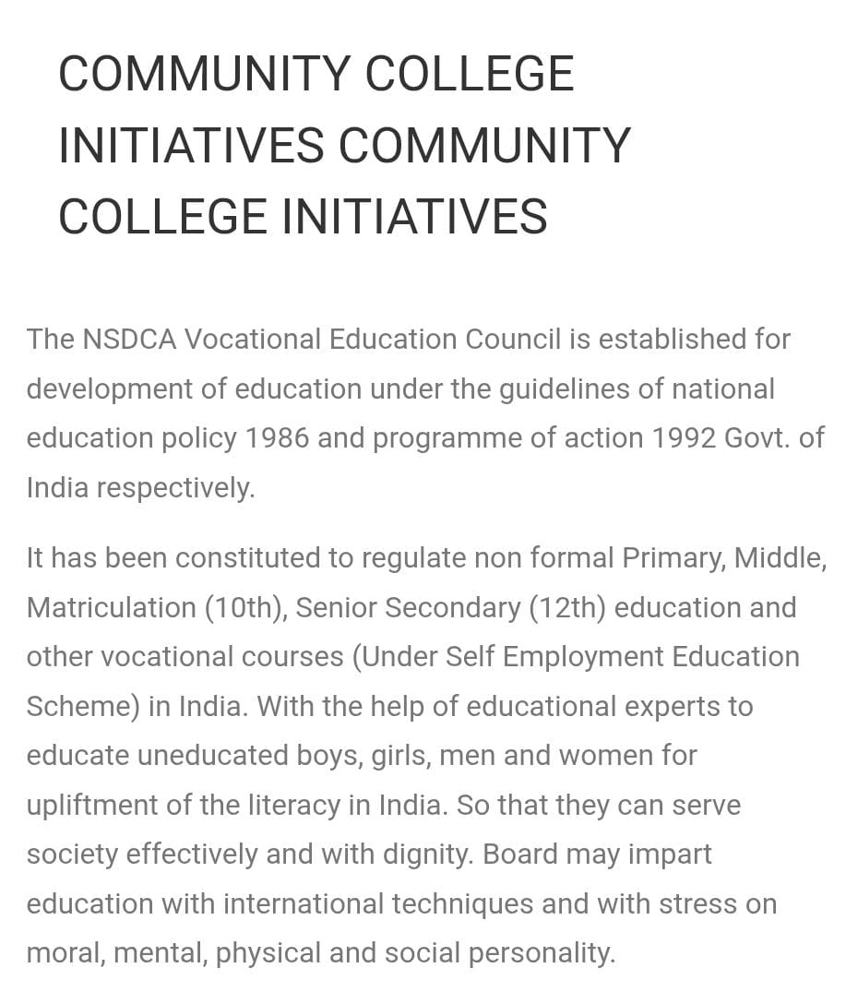

* Skill Development Initiatives
The NCVSTC Vocational Education Council is established for development of education under the guidelines of national education policy 1986 and programme of action 1992 Govt. of India respectively.
It has been constituted to regulate non formal Primary, Middle, Matriculation (10th), Senior Secondary (12th) education and other vocational courses (Under Self Employment Education Scheme) in India. With the help of educational experts to educate uneducated boys, girls, men and women for upliftment of the literacy in India. So that they can serve society effectively and with dignity. Board may impart education with international techniques and with stress on moral, mental, physical and social personality.
Like all educational boards/Universities ours is also an autonomous body. Each educational organization acts on its own discretionary powers. According to these powers every board / university / state Govts. / Central Govt. of India has the liberty and right to take its own decision either to allow or refuse any admission / service. But we do our best to make success the non formal education programme. All the education programme run by the board is board's own autonomous education programme. Legality, Validity, Utility of the education programme is strict conformity with the constitution of India and law of the land under Article 19(1)G, 29 & 30.
Recognition of Degree/Diploma by Govt. of India
NOTIFICATION NO. P 26/4/52 C.C.
GOVERNMENT OF INDIA
Ministry of Home Affairs
New Delhi
Dated : 20th September, 1952
Subject: Recognition of the Examination
According to Ministry of the Home Affairs Government of India. Notification No. 26/4/52 C.C. Dated 20/09/52 issued in consultation with the Union Public Service Commission, that in case of Degree/Diploma awarded by Board & University in India which are in corporate by one Act of Central or part & State Legislature in India. No formal orders. Recognized automatically for the purpose of employment.
Harish Chandra
Under Secretary Government of India
Under Human Rights Protection Act 1993, autonomous body have been given special protection and consideration. According to J.P. Unnikrishnan Vs Govt. of Andhra Pradesh AIR 1993 Supreme Court 2178 verdict voluntary organization like Trusts, Societies etc. have right to spread education and issue Certificates for Degrees/Diplomas Courses.
The NCVSTC /Council Director/members has the constitutional right under Article 19 (1) (g) to pursue any profession or any occupation and running teaching institutes have been included as part of occupation as held by Hon'ble Supreme Court in T.M.A. Pai Foundation Vs. State of Karnataka (SC) 2003 (2) SCT 385. The relevant portion of the above said judgment is reproduced as under:-
Private education is one of the most dynamic and fastest growing segments of post-secondary education at the turn of the twenty –first century. A combination of unprecedented demand for access to higher education and the inability or unwillingness of government to provide the necessary support has brought private higher education to the forefront. Private institutions with a long history in many countries, are expanding in scope and number, and are becoming increasingly important in parts of the world that relied almost entirely on the public sector.
Under HUMAN RIGHTS PROTECTION ACT ,1993 autonomous bodies have been given special protection & consideration.( For further details refer: AIR 1993 SC-2178.
Features:
• Our motto is Education, Health & Character.
• To give the best possible teaching and training to its students. So they can serve society effectively and with dignity.
• Democratizing higher education by taking it to the doorsteps of learners.
• Providing assess to high quality to all those who seek it irrespective of age, region or formal qualifications.
• Offering need based academic programmers by giving professional and vocational orientation to the course.
• To promoting and developing distance education in India & Abroad.
• To individualized study: - flexibility in terms of place and duration of study
• To give cost effective and self-employment education programme.
• Student support through the services network.
EXAMINATION
The final examination in theory and practical are held at the end of the academy year session in March/ April and in supplementary exams in Calendar year September/October. A candidate has declared successful on scoring minimum of 50-% marks in each paper. As per rule 3b-9.
CERTIFICATION
Every successful declared student will be awarded Diploma/Degree Certificate by the NCVSTC Vocational Educational Council in each education programme. As per rule 3b-9.
AGE& SEX
There will be no restriction of age, caste, sex, region, country under skill development programme, vocational education, and distance education system of the board.
MEDIUM
The medium of each education programme will be according to their Regional Language/ State Language/ Country Language. But Question Paper Will be published only in English / Hindi, student can give answer in english/ hindi or his/ her state language. But it should be mentioned earlier in the examination form.
ATTESTATION OF CERTIFICATES
The Certificates of the NCVSTC Vocational Education Council get Attestation from Foreign Embassies for Education and Employment purposes. Being a NON-UGC Programme, the Certificates of the NCVSTC are not recommended for PSC/UPSC Appointments. It is widely used in Public Sector Undertakings, Multi-National Companies and Private Sector in India and abroad who are satisfied with the Official Verification System.

RULES & REGULATIONS
Check and satisfy necessary information about education programme / board before admission no responsibility of the institute / board after that.
Fees once paid should not be refunded or changed under any rule.
Every student abides to and obtains to present rule and regulations and directions of the institute/ board and also those which are to be enforced time to time.
Any change of the rules & regulation directions by the exam body shall be acceptable to the student.
The Board / organization run non-formal self-employment education programme only and not give any guarantee for further educational use or any job.
If any document found bogus the admission and result should be canceled automatically without any notice.
If student fails to deposit the fees in the due time the admission should be canceled without any notice and any primary deposit fees should not be refunded.
If study material or documents will be lost in the post no responsible of the institute / board.
If any student / members / teachers / employees of any institute / center have any dispute with the board / institution it will be resolved through the committee appointed by the NCVSTC Vocational Education Council under Indian Arbitration Act 1940. The decision of the arbitrator shall be final and binding on all parties, Direct Court will not be permissible.
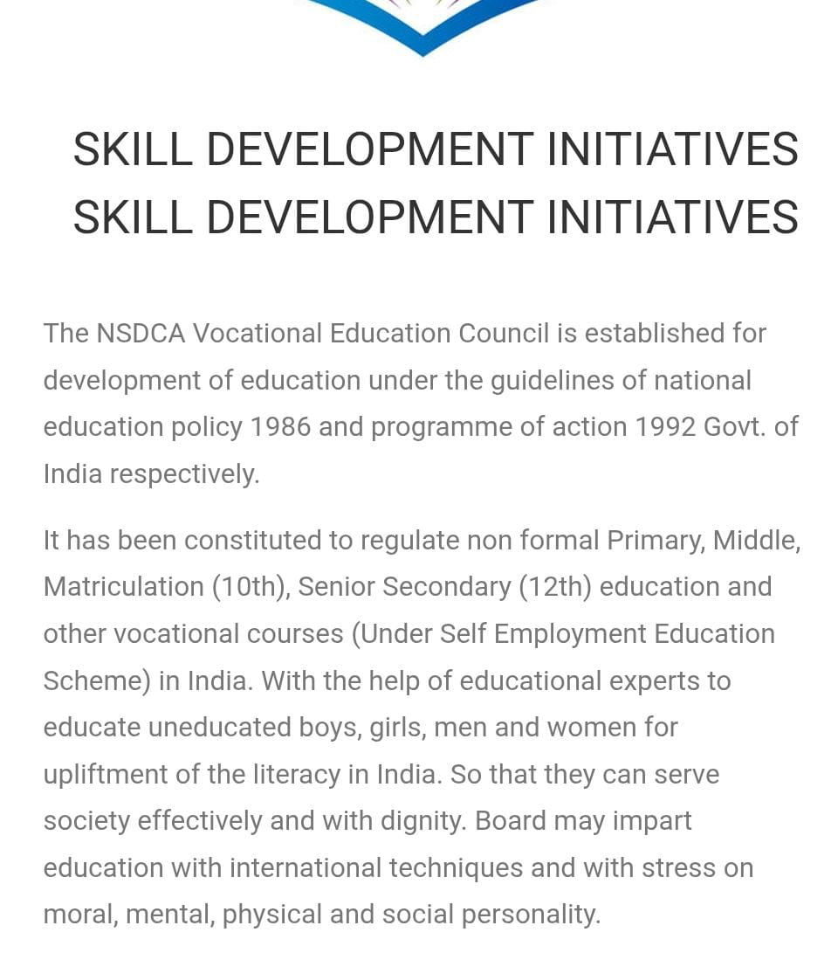

- Resources & Important Links
- NCVSTC Question Bank
- NCVSTC Syllabus
- NCVSTC Study Materials
- Student Login

  - NCVSTC Question Bank

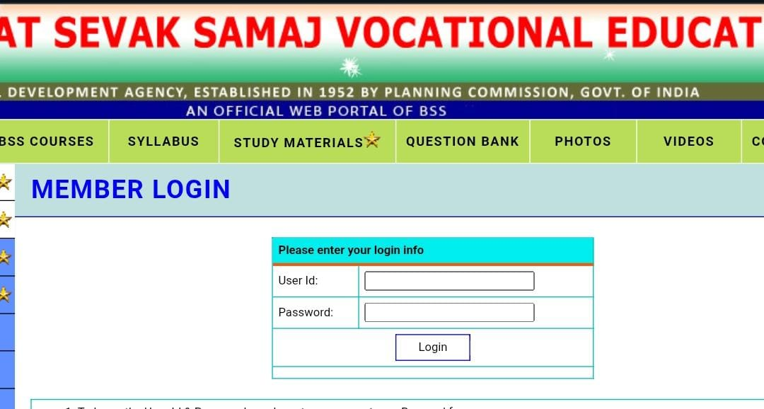

  - NCVSTC Syllabus

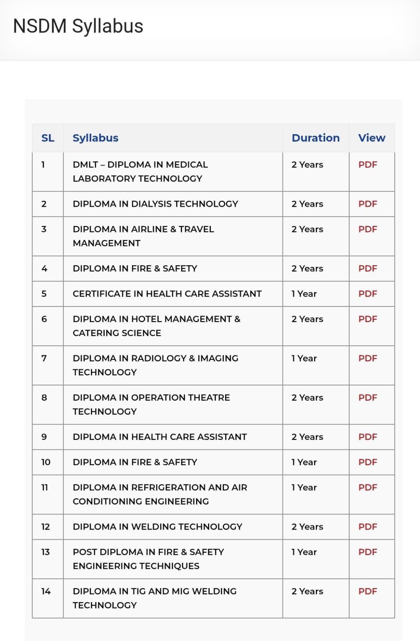

  - NCVSTC Study Materials

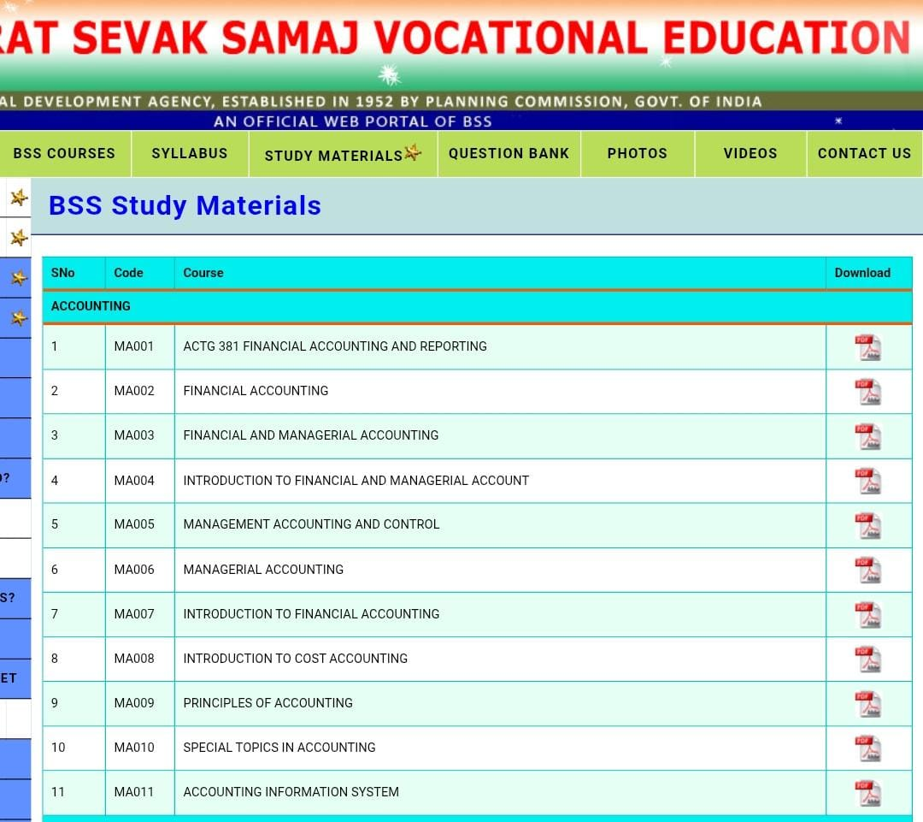

  - Student Login

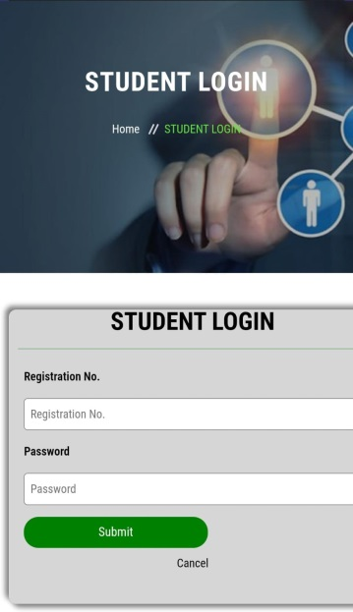

- Registration

- Offline Registration
- Online Registration
- Internship Application

- Offline Registration

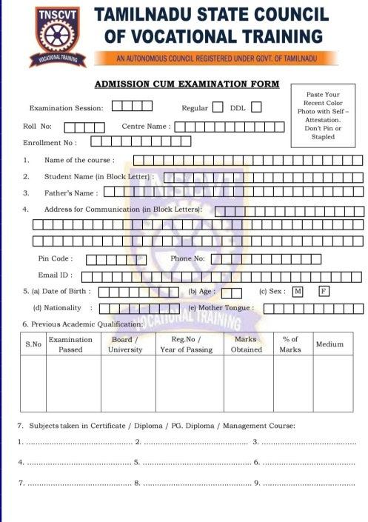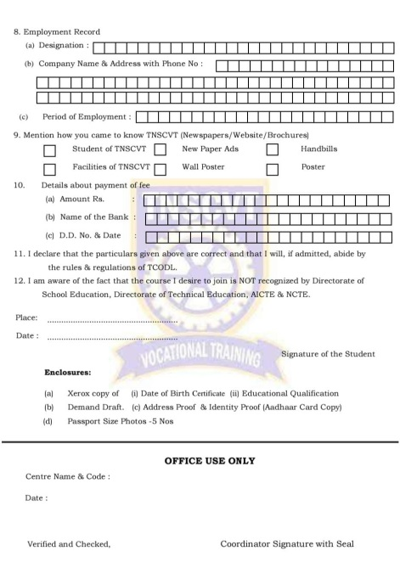

- Online Registration

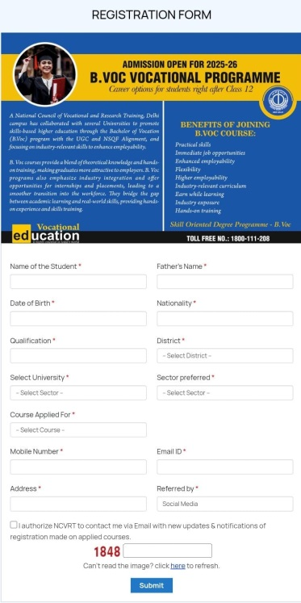

- Internship Application

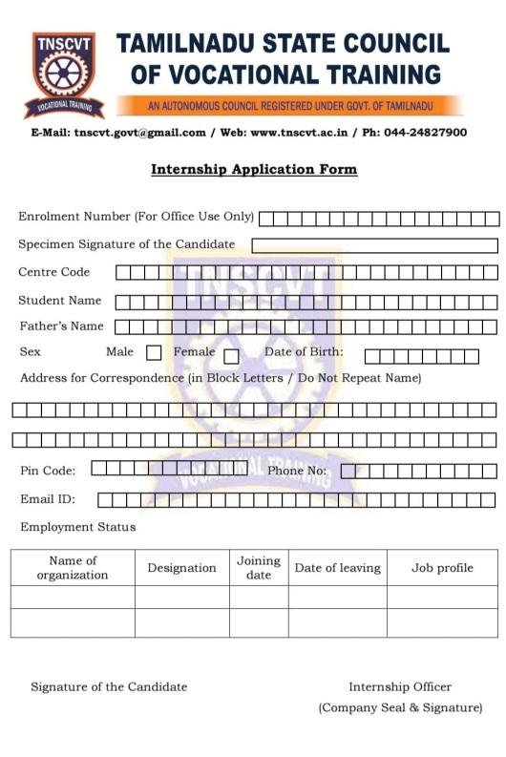

- Examination & Results
- Exam Schedule
- Exam Center
- Result

  - Exam Schedule
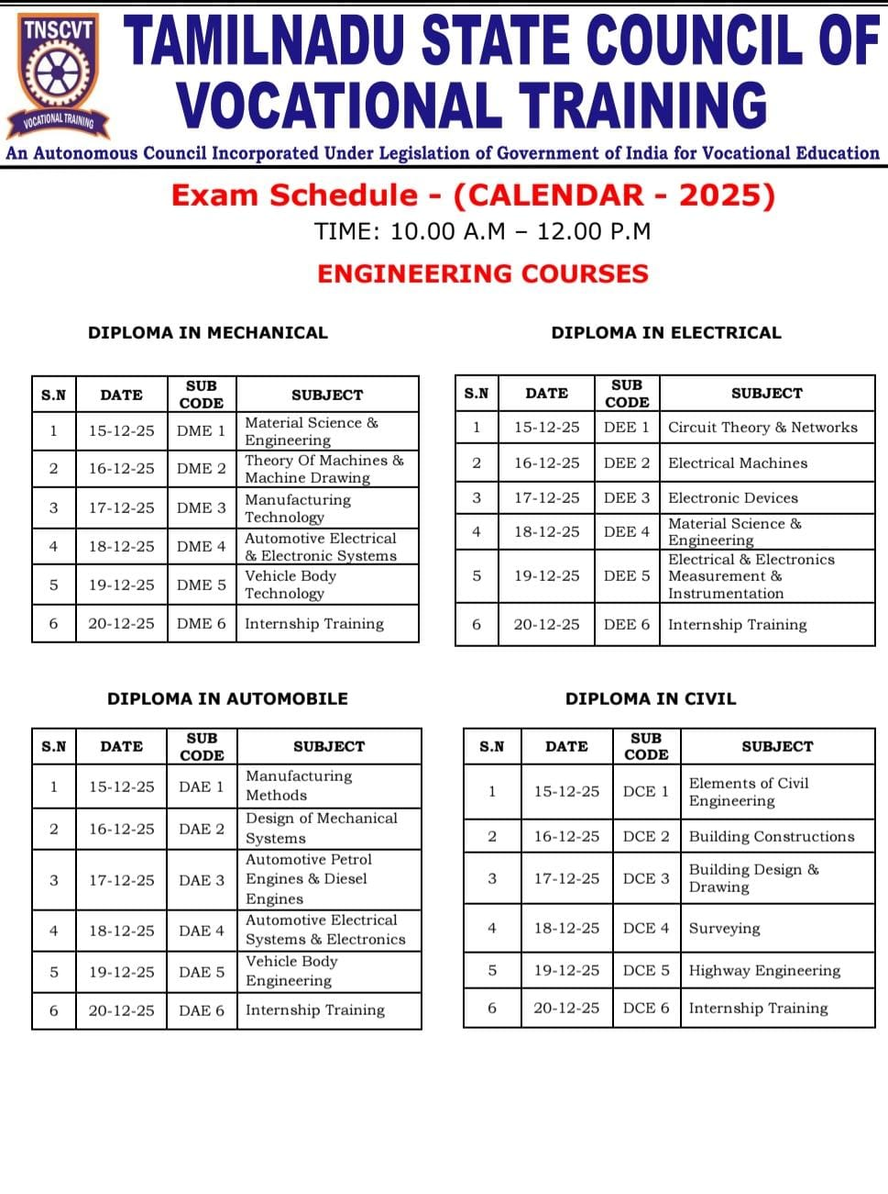

  - Exam Center
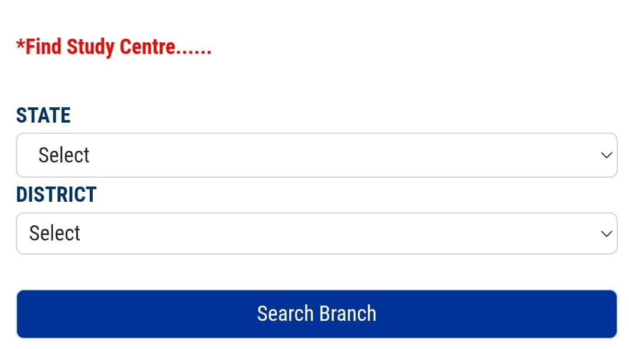

  - Result

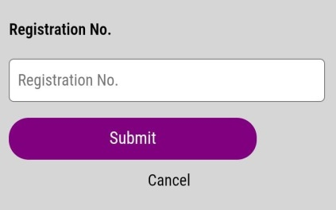

- Online Verification
- Certification Verification
- Marksheet verification
- Verify Document
- Model Certificates

  - Certification Verification

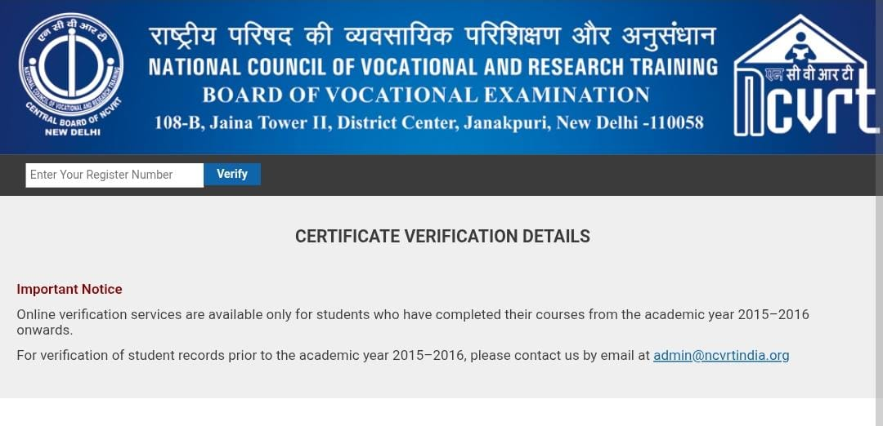

  - Marksheet verification

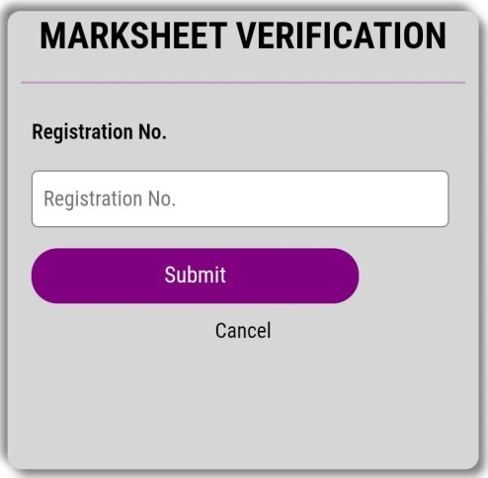

  - Verify Document
Procedure
Anyone can apply for verification of original / photo copy of documents like Detail Marks Certificate / Certificate etc. issued by the board.
Individual / companies / organizations / agencies / Govt. departments / Embassies who would like to verify the authenticity of the academic documents may have to following this procedure:
1. Send a Demand Draft of Rs. 1000/- ( non-refundable ) for each documents Drawn in favour of :
” Navigating Career For Vocational Skill Technology Council “ payable at Pappireddipatti.
2. Add Rs. 100/- postal charges Extra in India and Rs.2000/- for out side of India .
3. No Verification charges for Central / State Govt. Departments and Embassies
4. Normal period required for verification 15 days.
NOTE: VERIFICATION BY TELEPHONE / FAX / EMAIL WILL NOT BE ENTERTAINED.
Send all documents by Regd. Post / Speed Post at
Admin. office:
Nehru Skill Development Mission
4/1958,Samiyapuram Koot Road,
Pattukonampatti-post
Pappireddipatti-Tk
Dharmapuri-Dt. Pincode:636905.
Tamilnadu. india
Mobile:9585343052 , 8270923781

  - Model Certificates
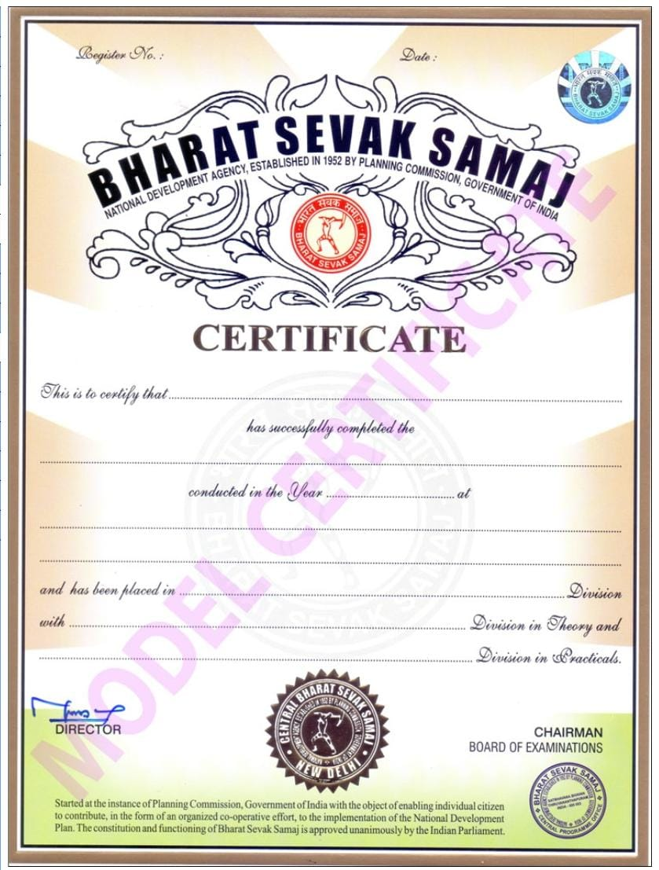

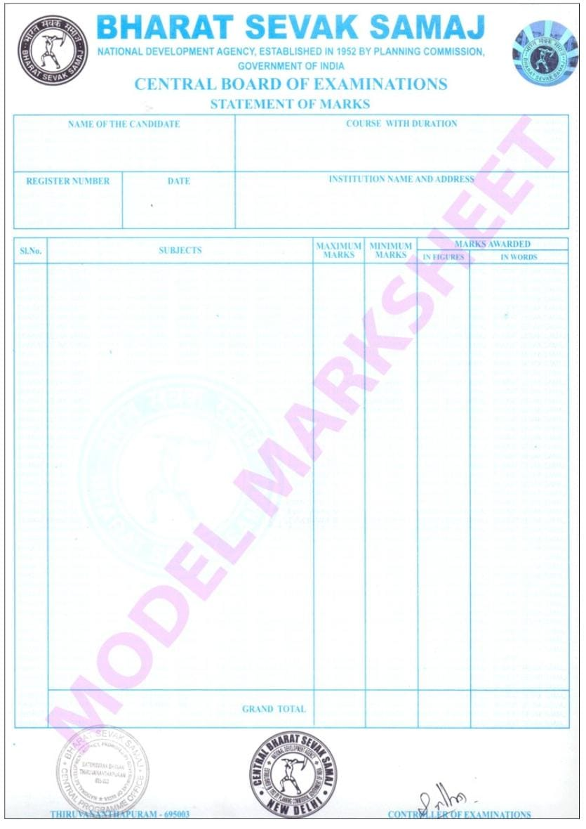

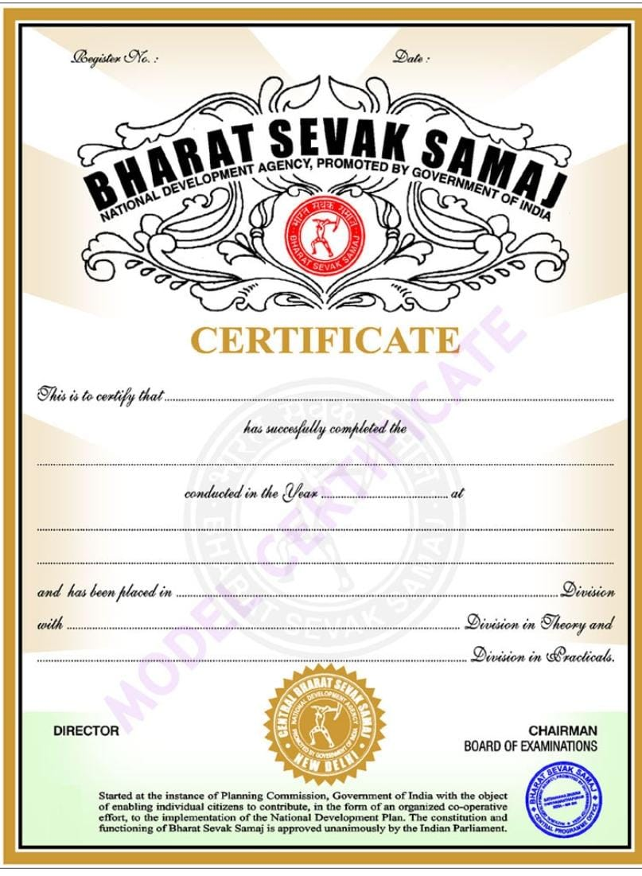

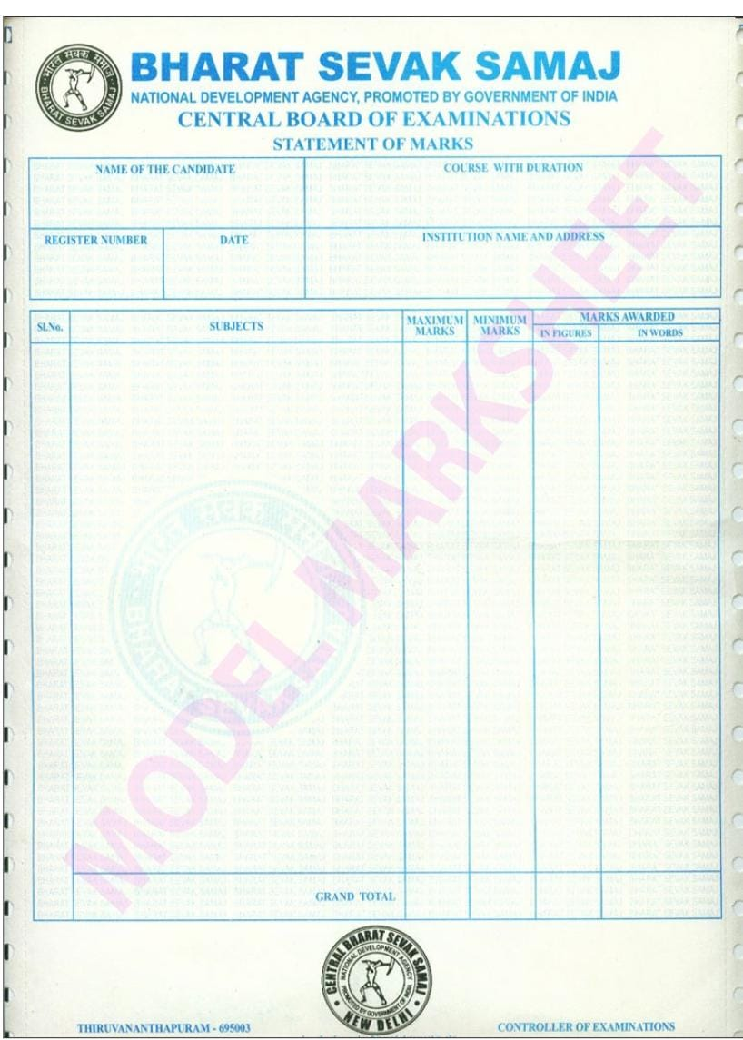

- Contact & Support
- Contact us
- Gallery
- Payment method

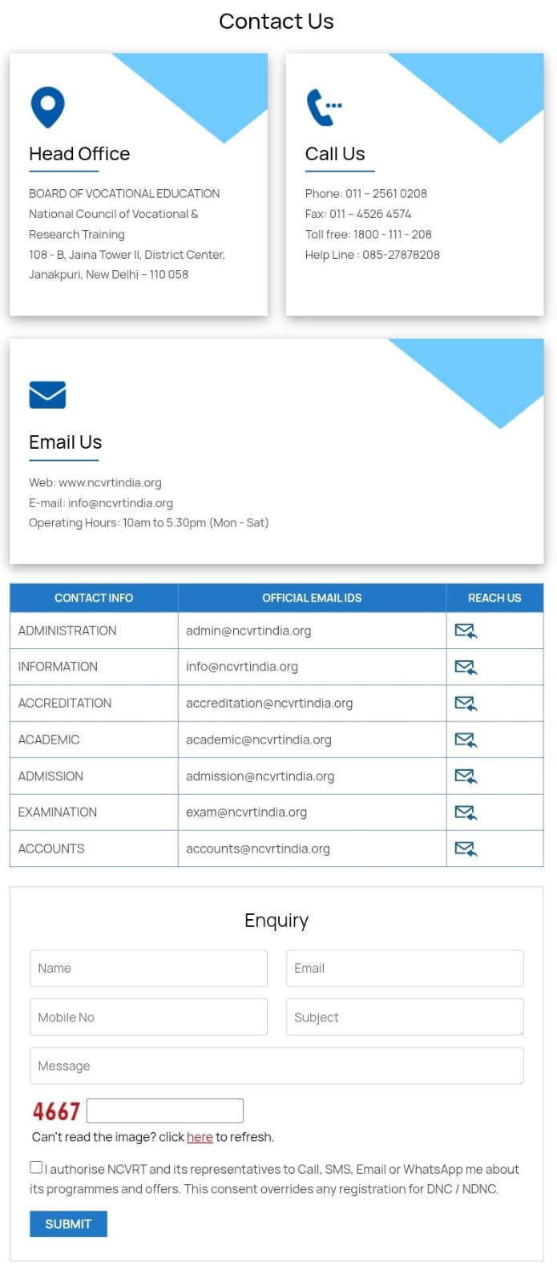

  - Gallery

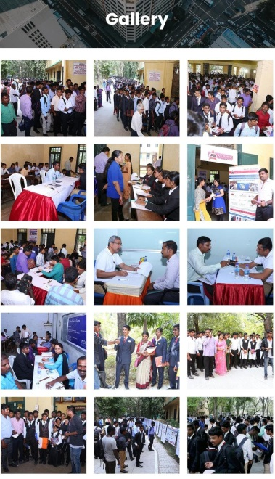

  - Payment method
The NCVSTC preferred payment option and must be used while making payment by Net Banking and Demand Draft favoring " NAVIGATING CAREER FOR VOCATIONAL SKILL TECHNOLOGY COUNCIL " payable at Chennai. The centre co-ordinator can deposit the affiliation and academic fees of those students who have already taken admission and have not deposited their full payment at that time.
NOTE: After depositing the fee in the bank account of NCVSTC, the fee deposit details and/ or fee deposit slips must be communicated to the NCVSTC through Fee intimation slip / Fee deposit slips. The centre co-ordinator can also email the Fee intimation slip details/ Fee deposit slips on the email address: info@ncvrtindia.org and upload the Fee deposit slip with below details.
